

student How-to

OC Performance Scheduling

Oklahoma Christian University

Table of Contents

1. Login Steps 2

a. Login 2

b. First Time User or in the Semester 4

2. Event Signups 7

a. Sign up for a Time Slot 7

I. Individual Signups 9

II. Group Signups 10

b. Request Time Slot 12

c. Request Additional Time Slots 13

d. Request Availability 14

e. Edit Signup 15

f. Delete Signup 16

3. Performances 18

4. Instruments 21

5. Repertoire 24

6. Logout 29

# Login Steps

## Login

* Navigate to the [Performance Scheduling website](https://performance.oc.edu/) (click on this link that goes to <https://performance.oc.edu/>).
* We use Google to authenticate our logging in.
* You must use your OC affiliated email address to login.
  1. Click Sign up with Google.

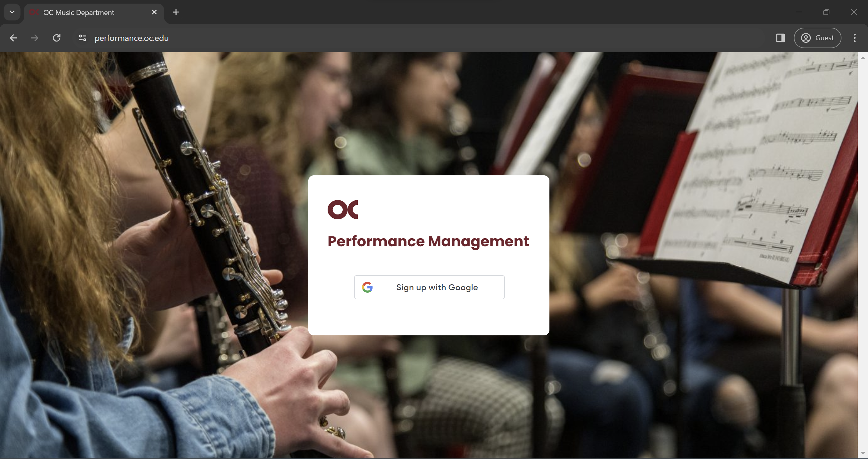

* 1. Enter your **OC** email.

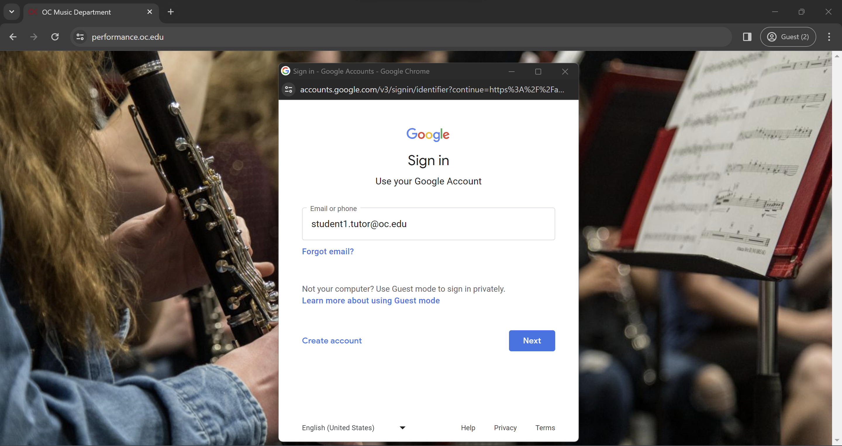

* 1. Enter your **OC** credentials.

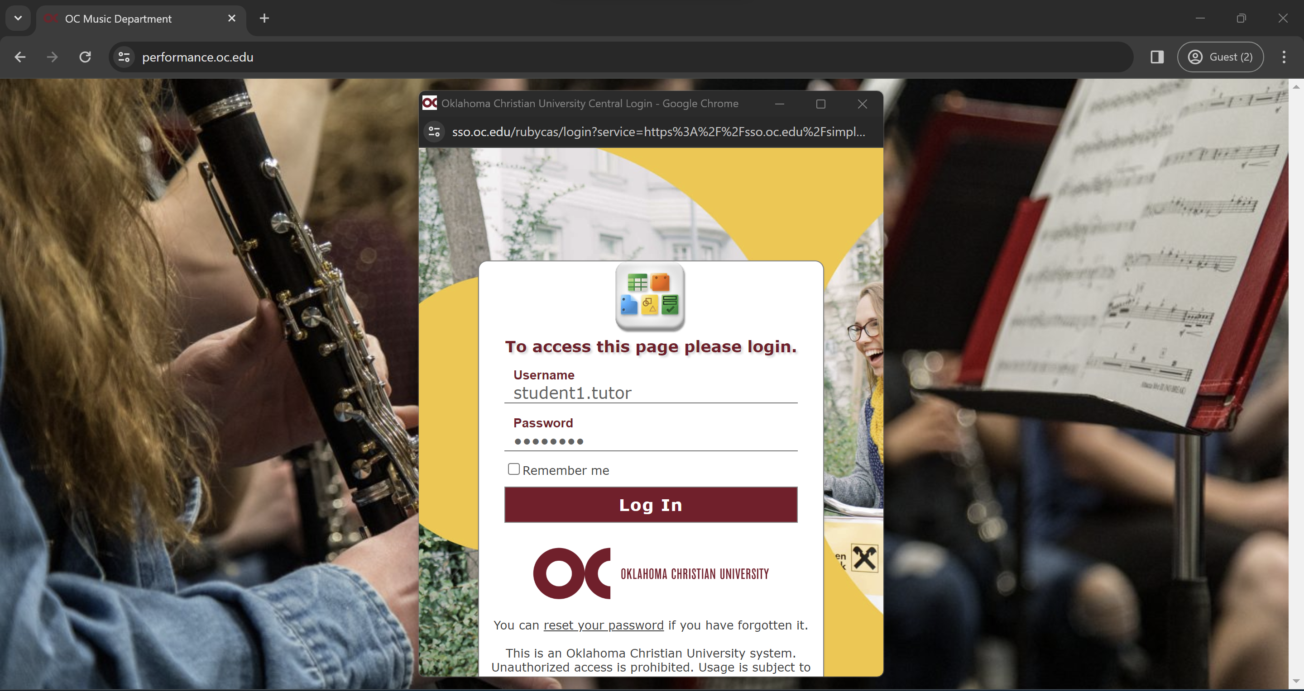

* 1. Click on the account you logged in with.

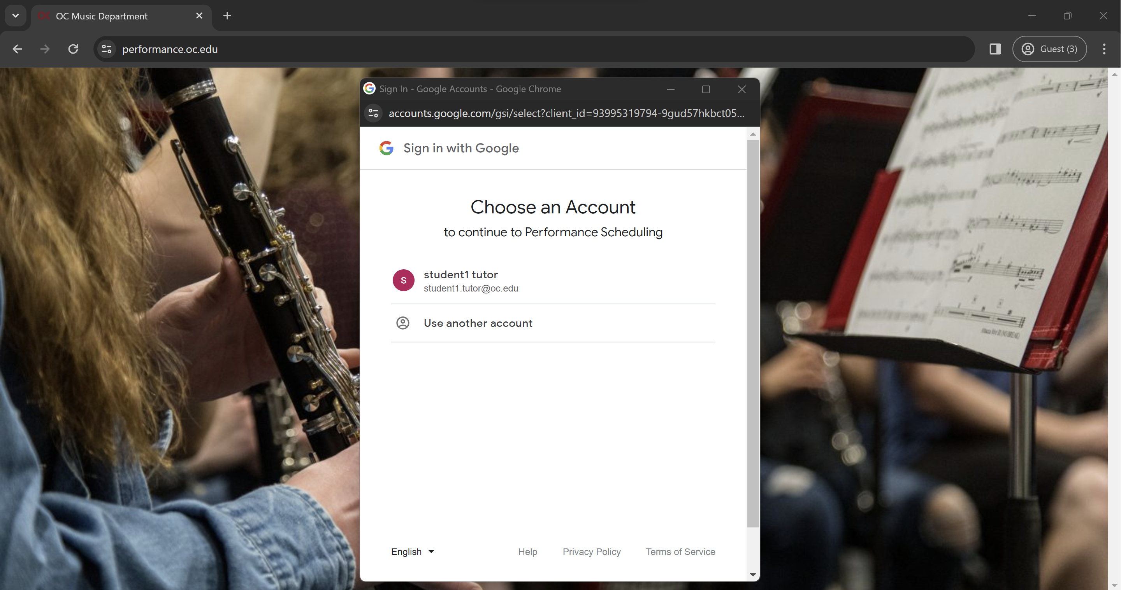

* 1. Google may ask you to give permission to share information with this site. If it does, please give the permission.

## First Time User or in the Semester

* When you log in for the first time, you must activate your account so that you can properly use the website.
  1. Click Activate.

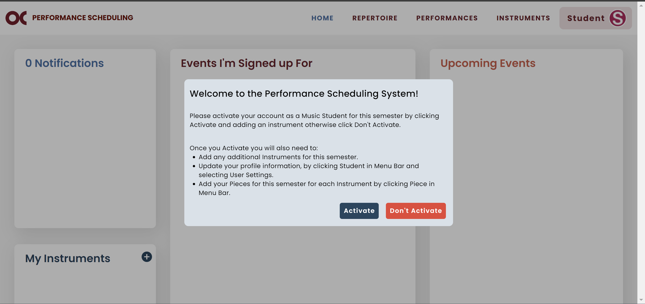

* 1. Add the instrument you will perform this semester (more instructions on page 22).

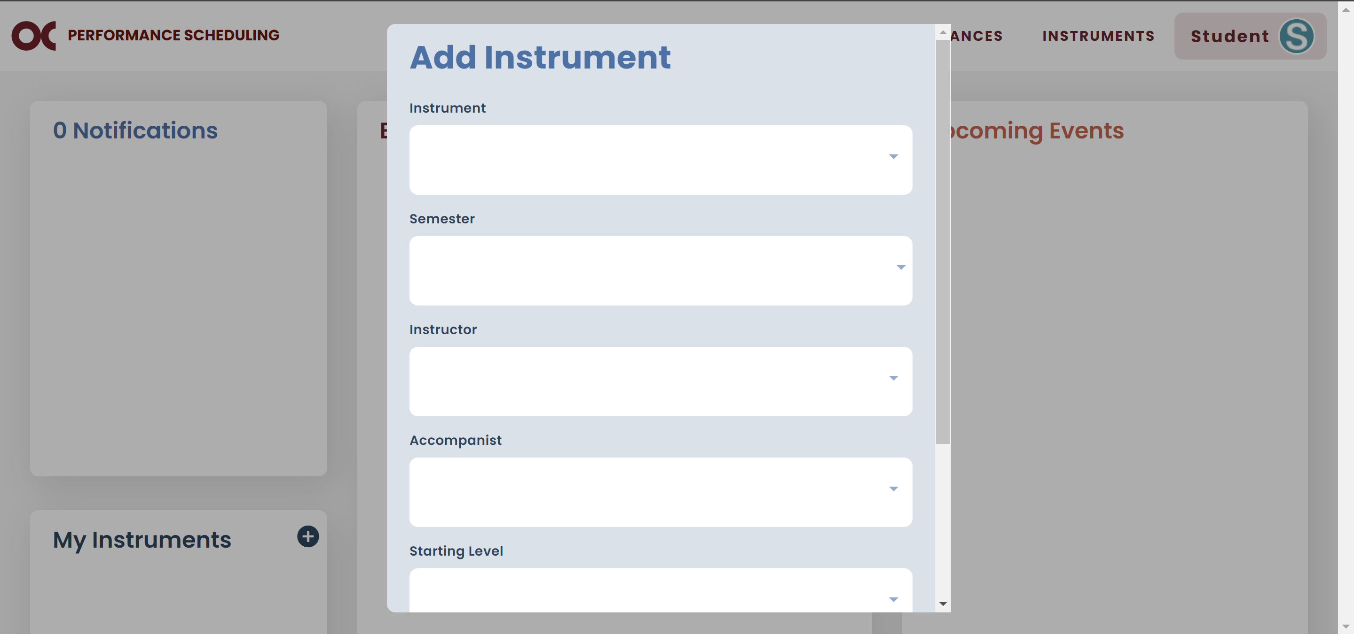

* 1. Click on Student and then User Settings.

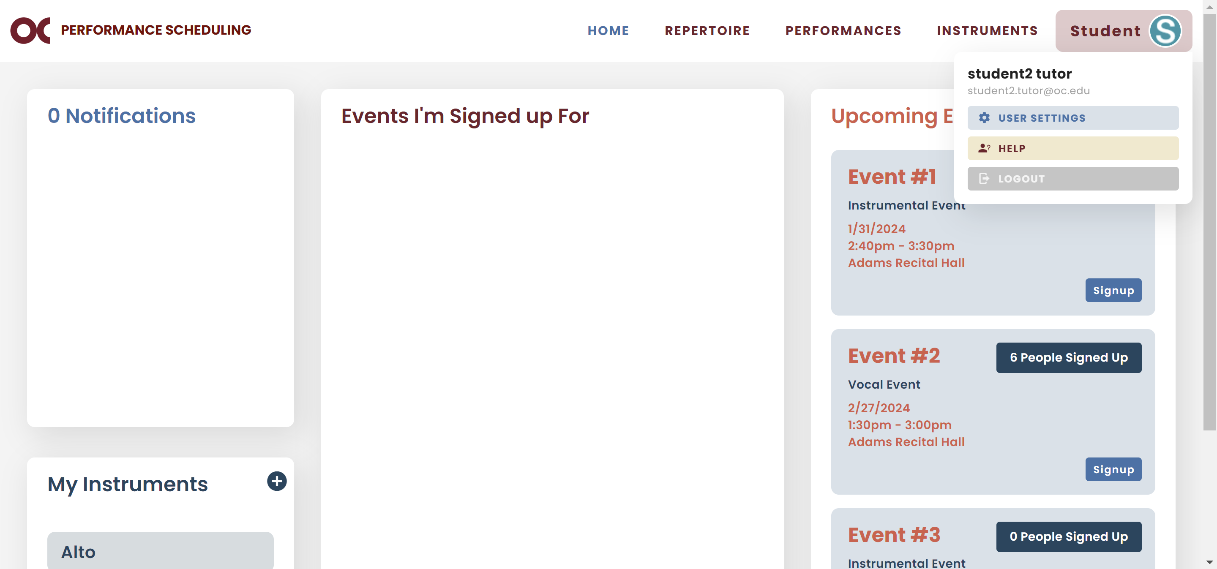

* 1. Update your profile information and click Save.

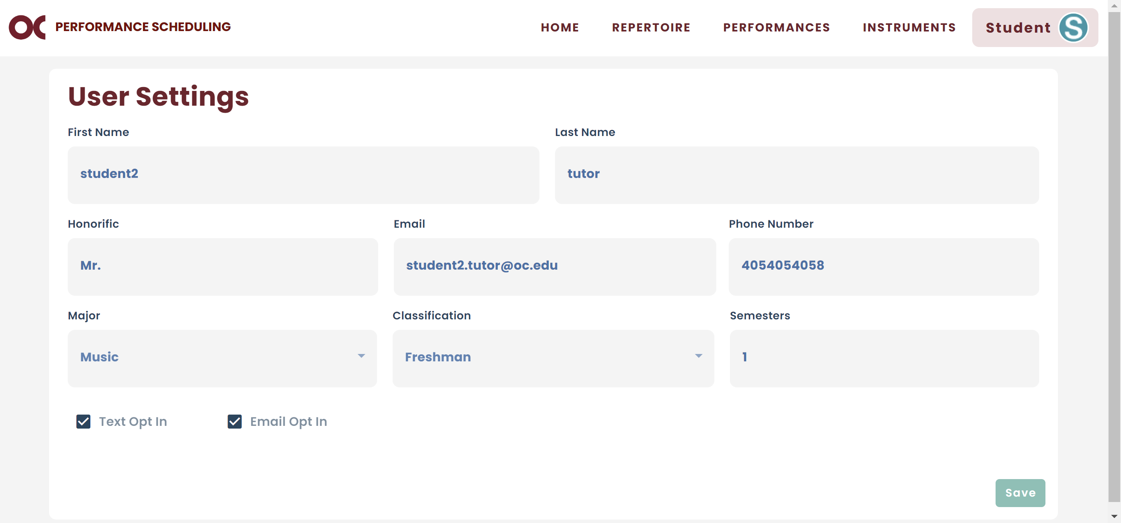

* 1. Go to your Repertoire and add the pieces for this semester (more instructions on page 25).

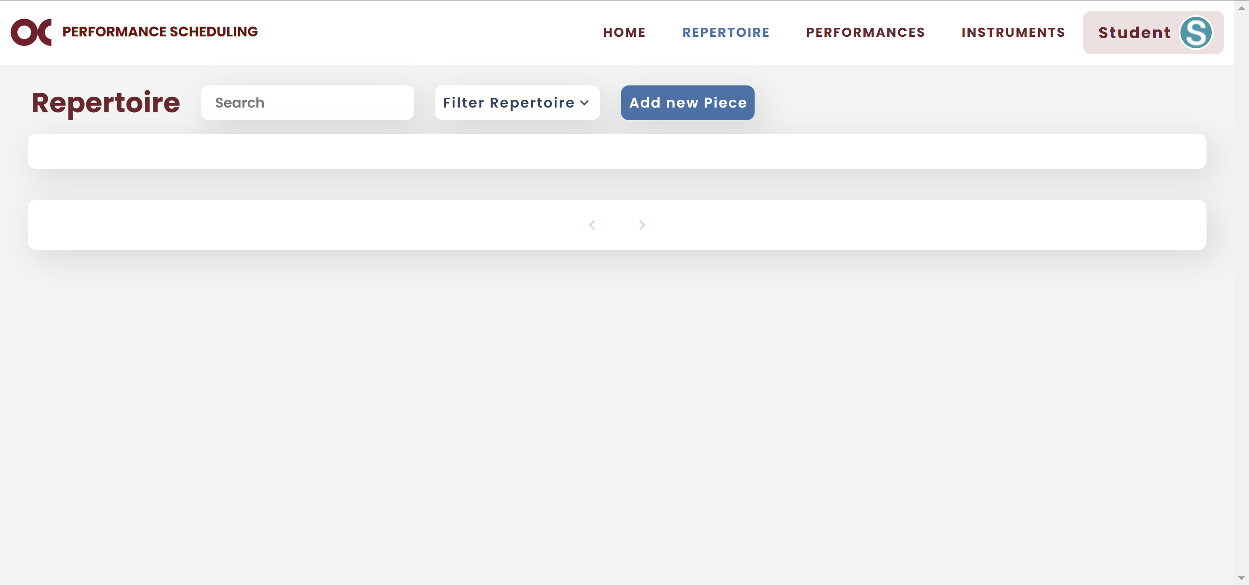

# Event Signups

* You can view all available events on your home screen.

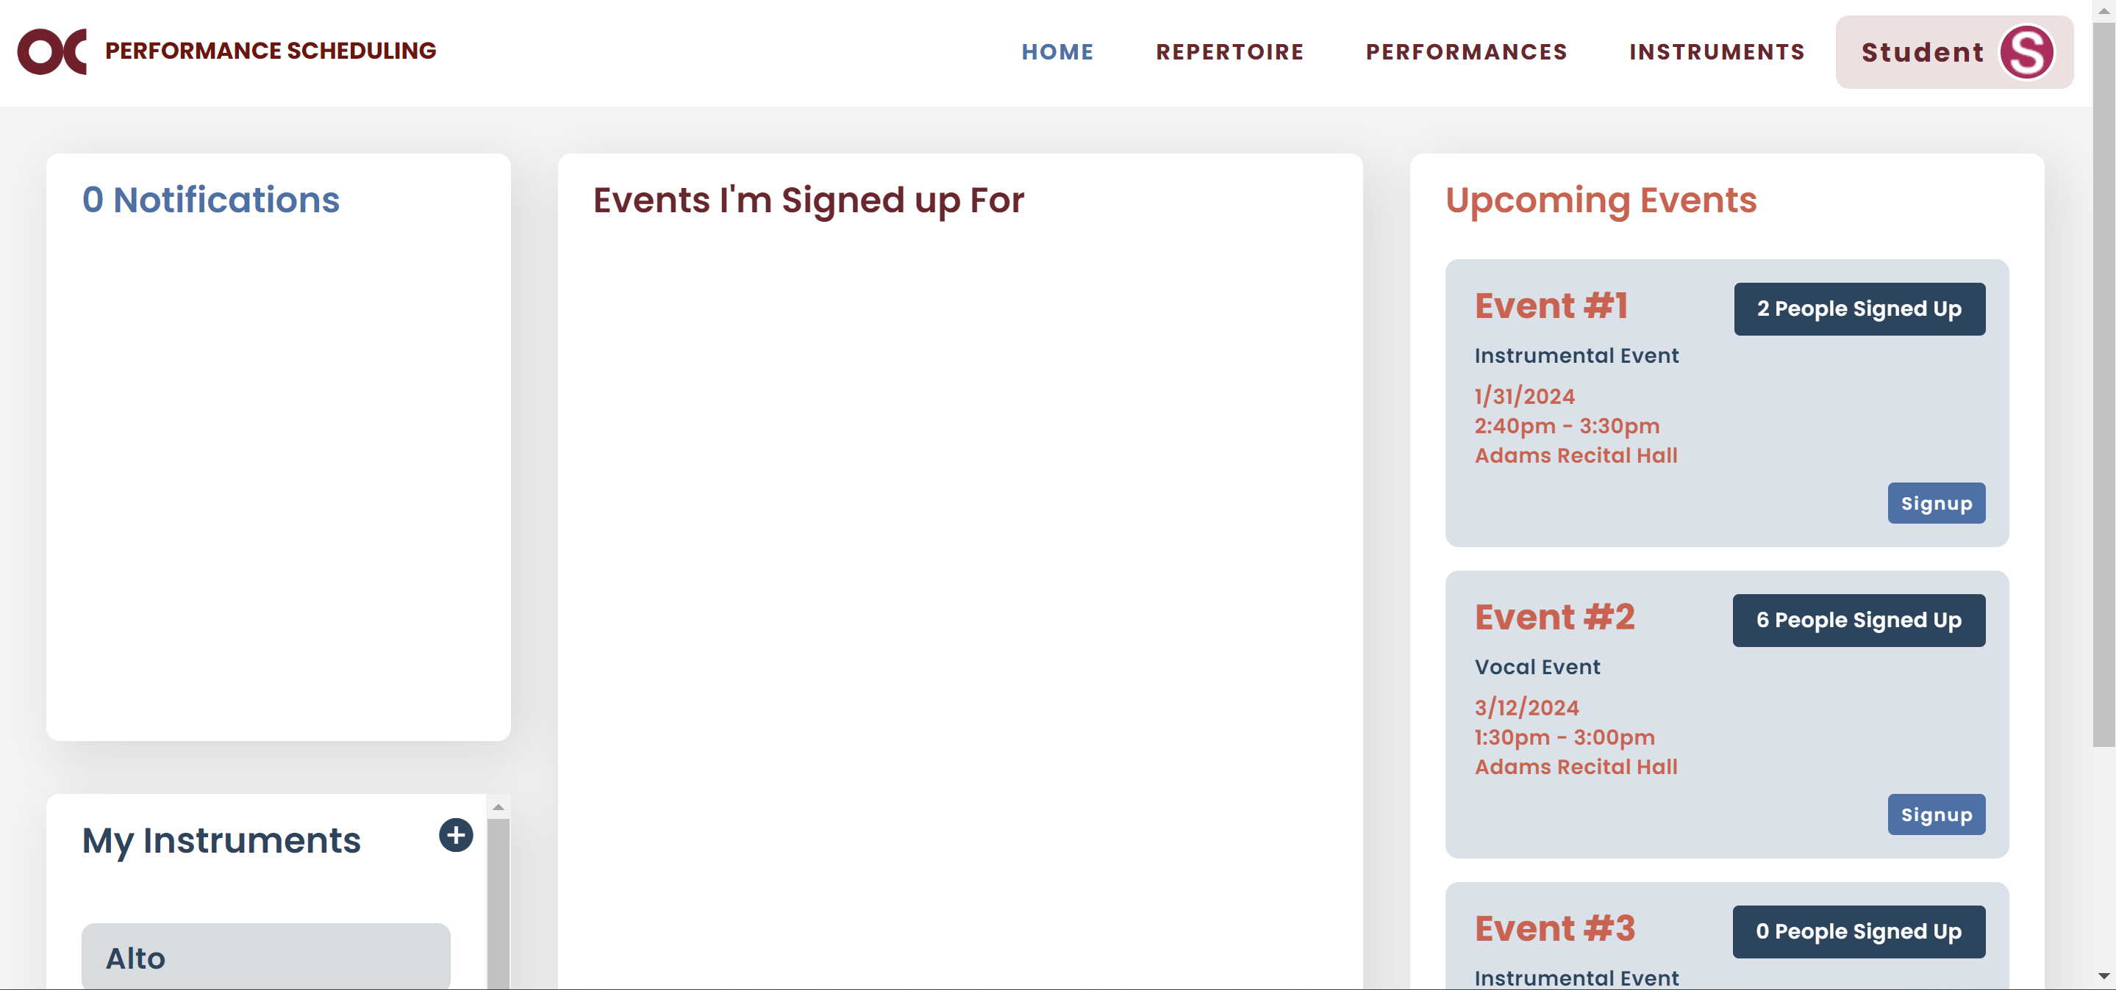

## Sign up for a Time Slot

* You will find your upcoming event and click on Signup.



* The signup screen will display availabilities for your private instructor and accompanist (if any).
* The grayed out slots are the ones your instructor and accompanist are not available.
* The red slots are spots already taken.
* The teal slots are available for sign up.
* The dark green slots are group signups.
  1. Select your instrument.
  2. If your instructor does not need to be present in your performance, you can clear that field and more slots will be available based on all faculty availabilities.

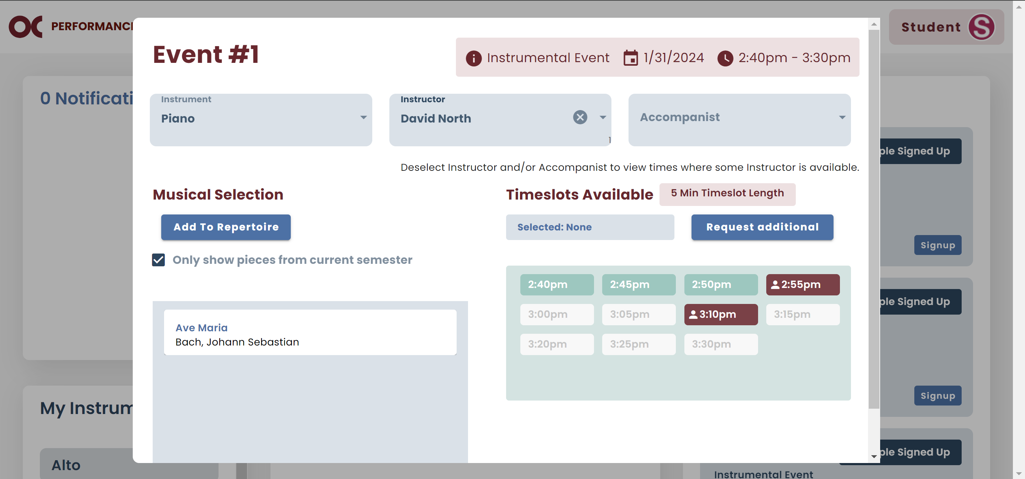

* 1. If you are performing only pieces from the current semester, select the pieces you are performing.
  2. If not, unselect the checkbox to display pieces from previous semesters, and select the pieces you are performing.

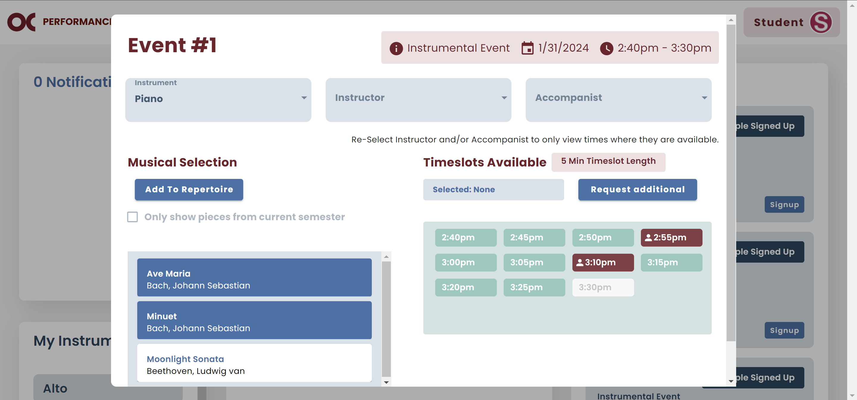

* 1. Pick one of the teal time slots.

### Individual Signups

* 1. Scroll down and click Sign up.

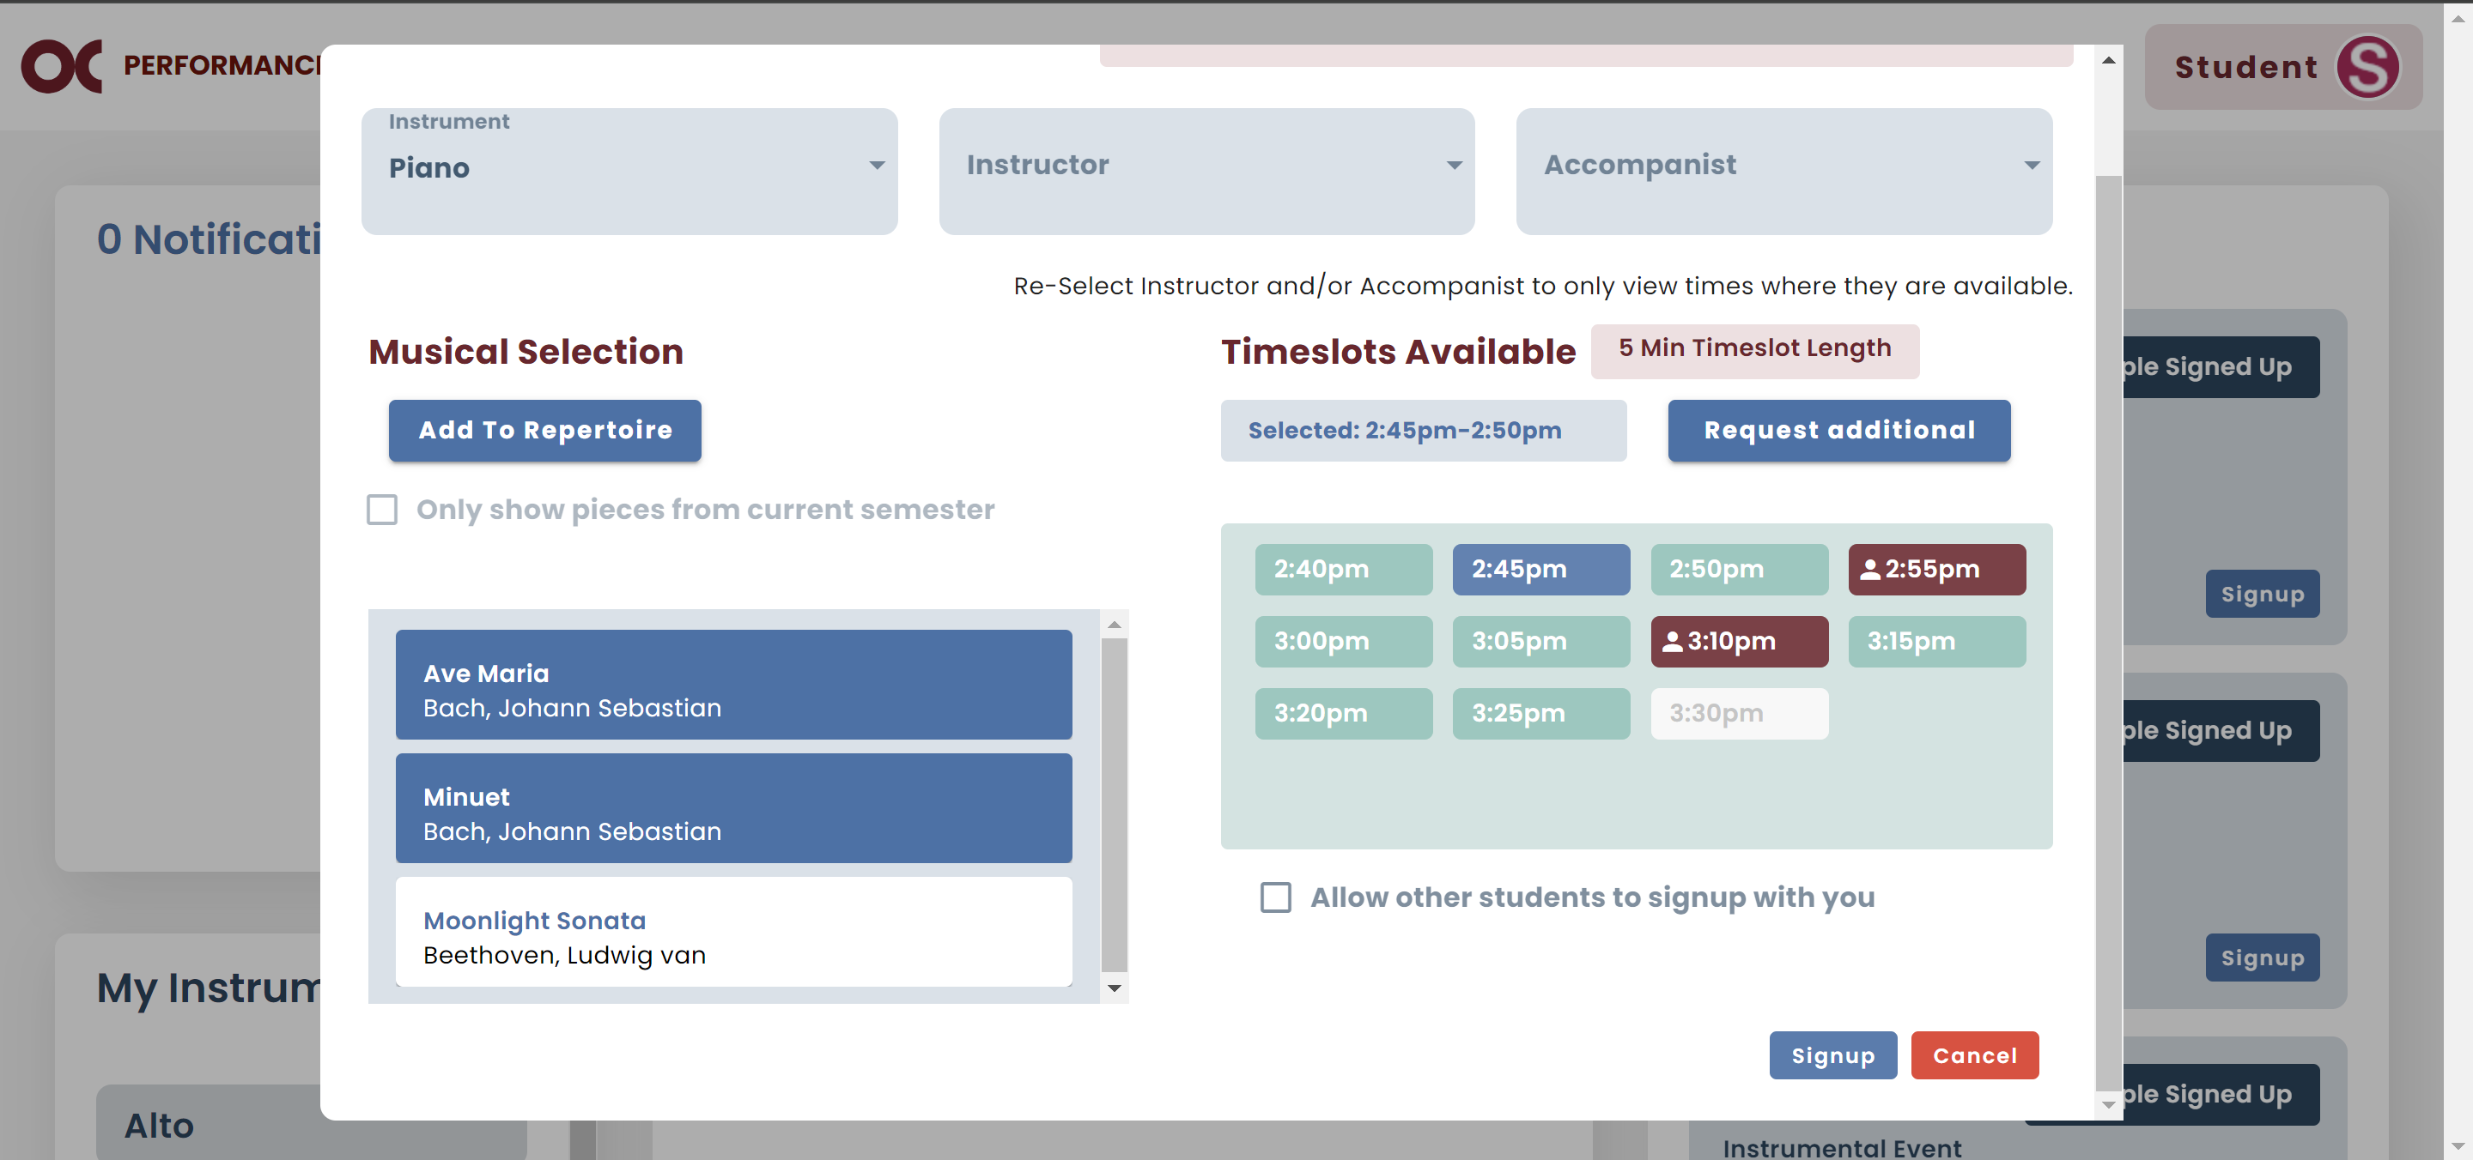

* 1. If all the information is correct, click Confirm.

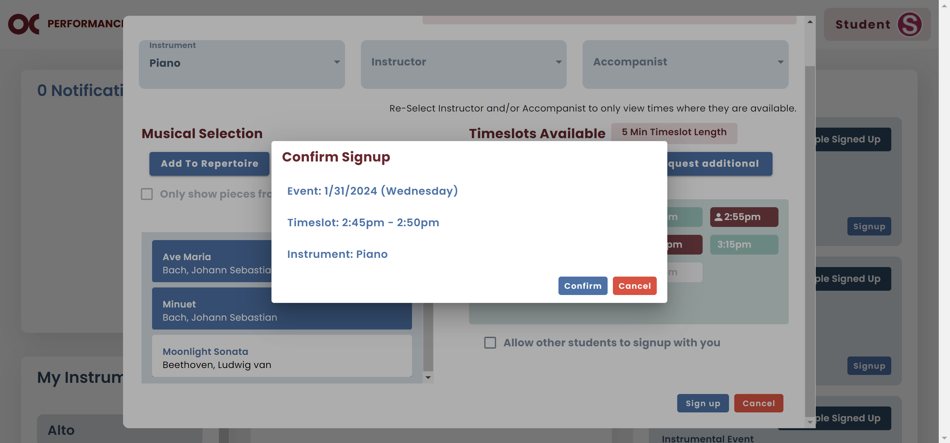

* 1. Now your signup will show on your home screen.

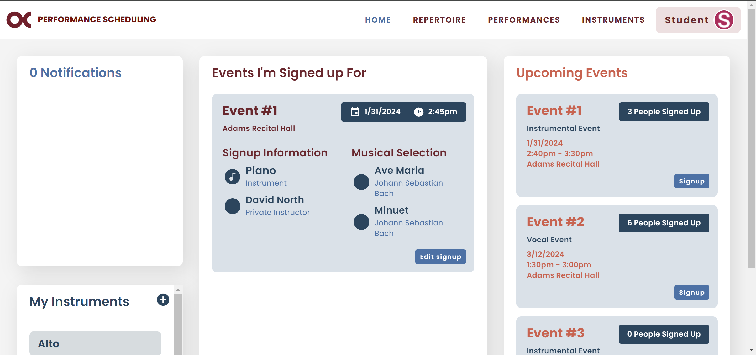

### Group Signups

* + 1. If you are the first member of the group to sign up, select an available time slot, then check the group checkbox, and click Sign up.

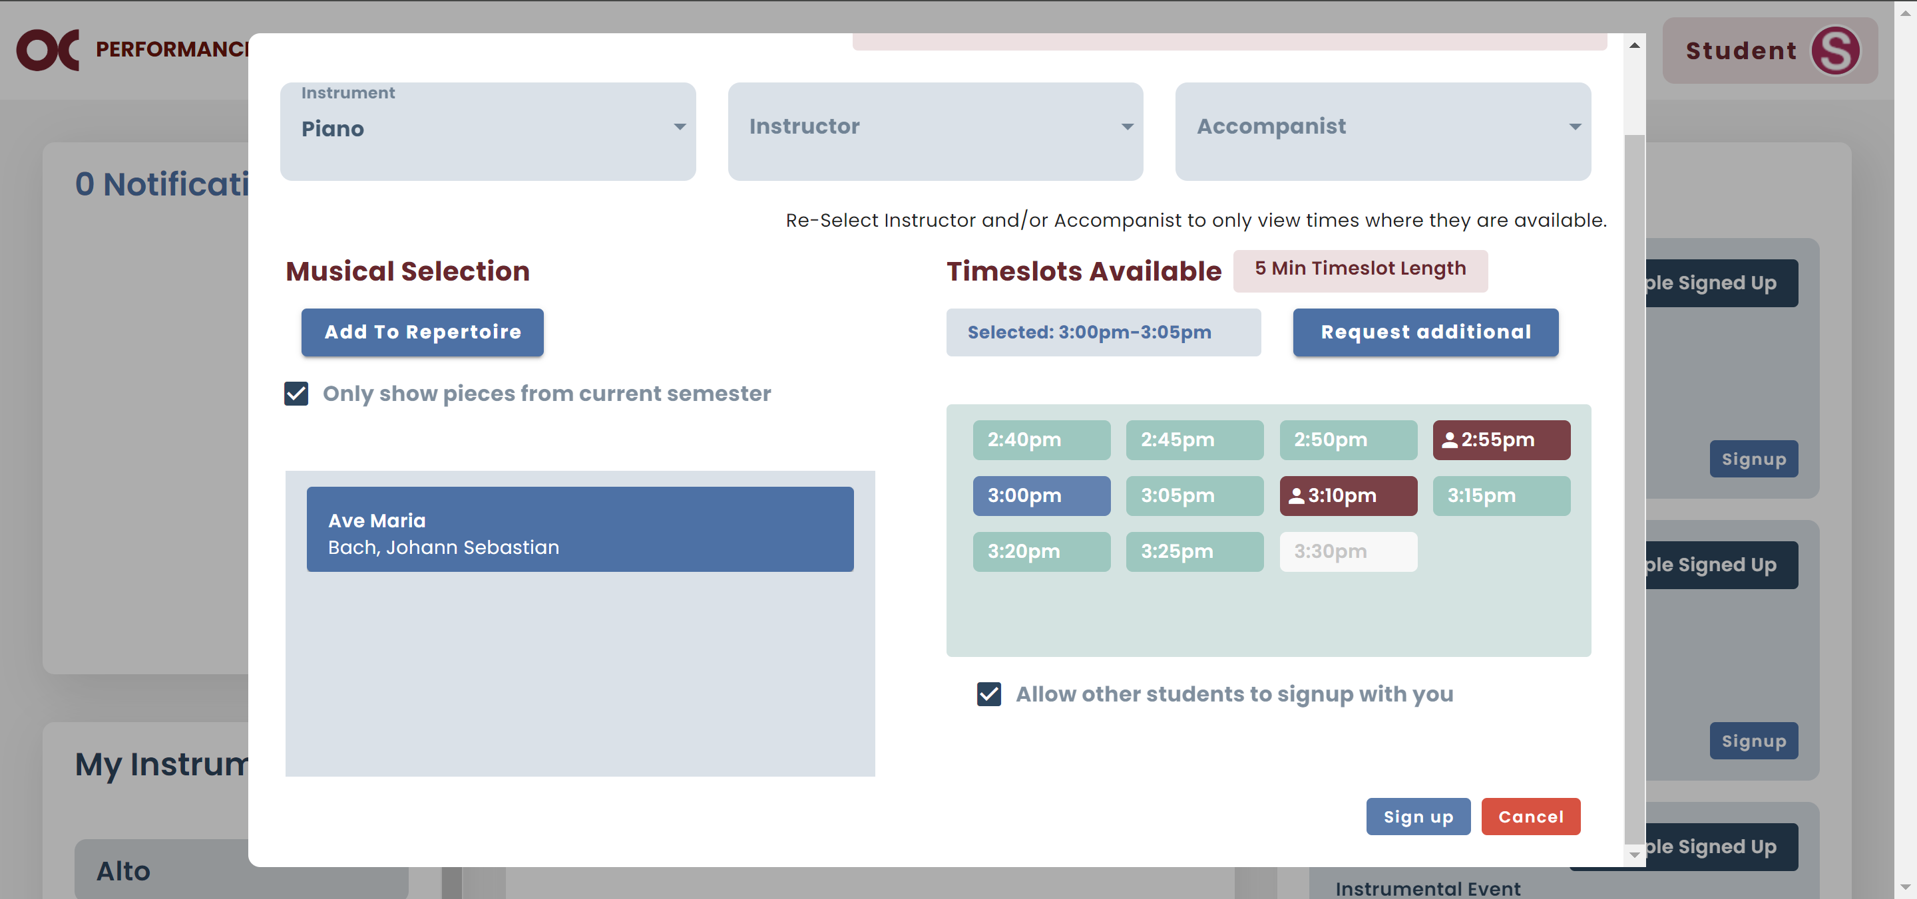

* + 1. If you are any other member of the group, select the dark green time slot that your group signed up for.

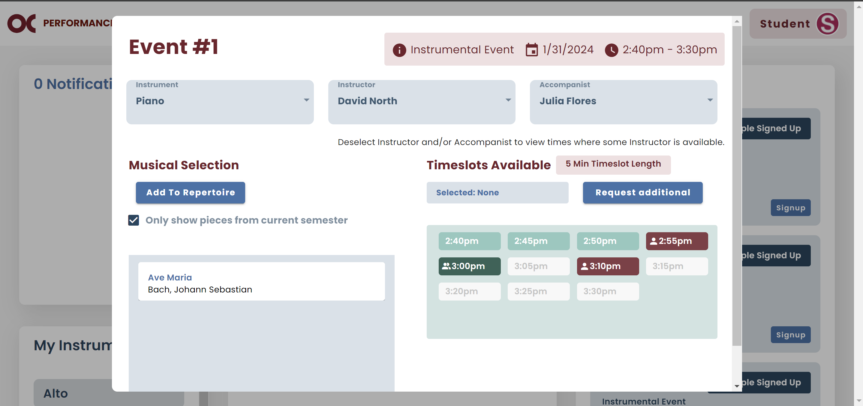

viii. If you do not have in your repertoire the pieces that will be performed picked by the first member of the group, you will have to add them to your repertoire.

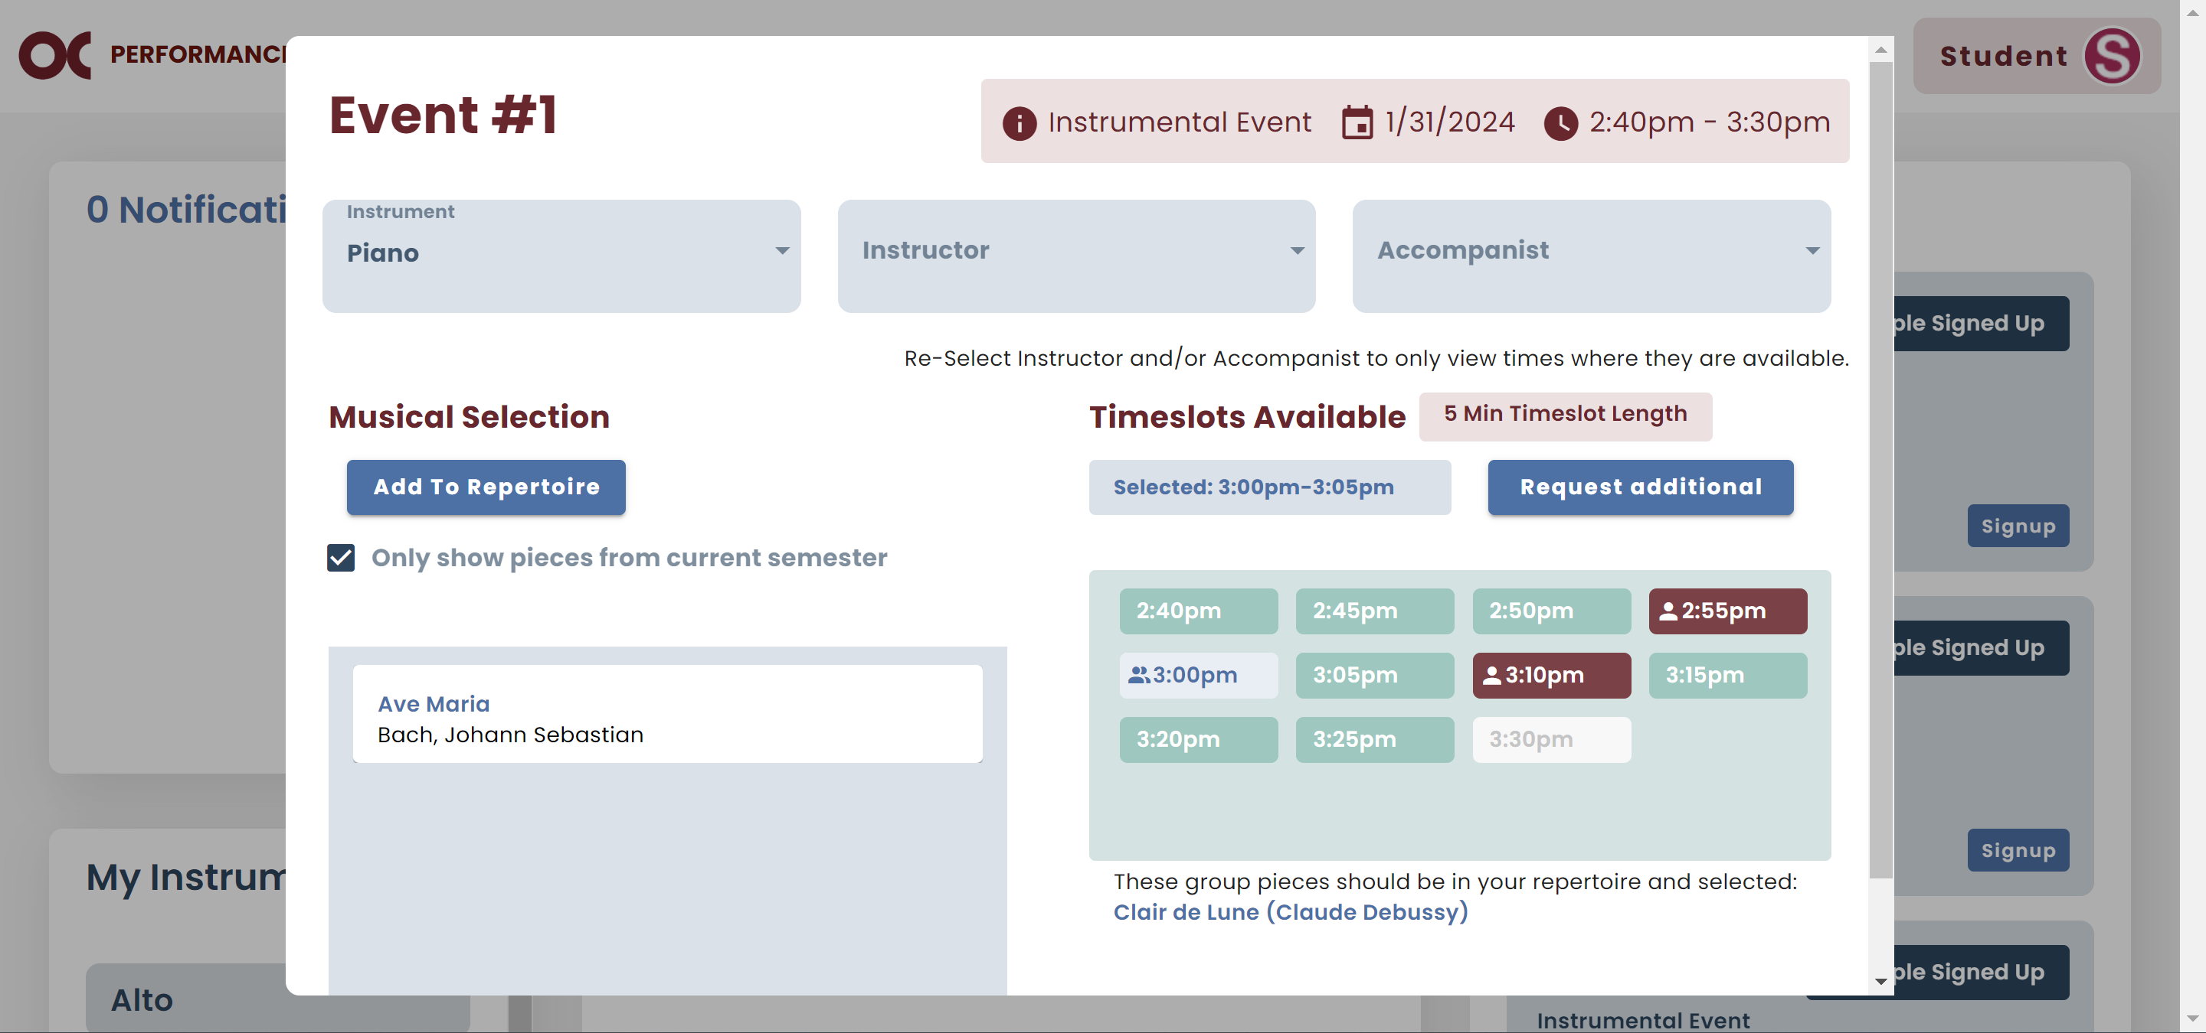

* 1. Once you add them, click Sign up.
  2. If all the information is correct, click Confirm Group Signup.

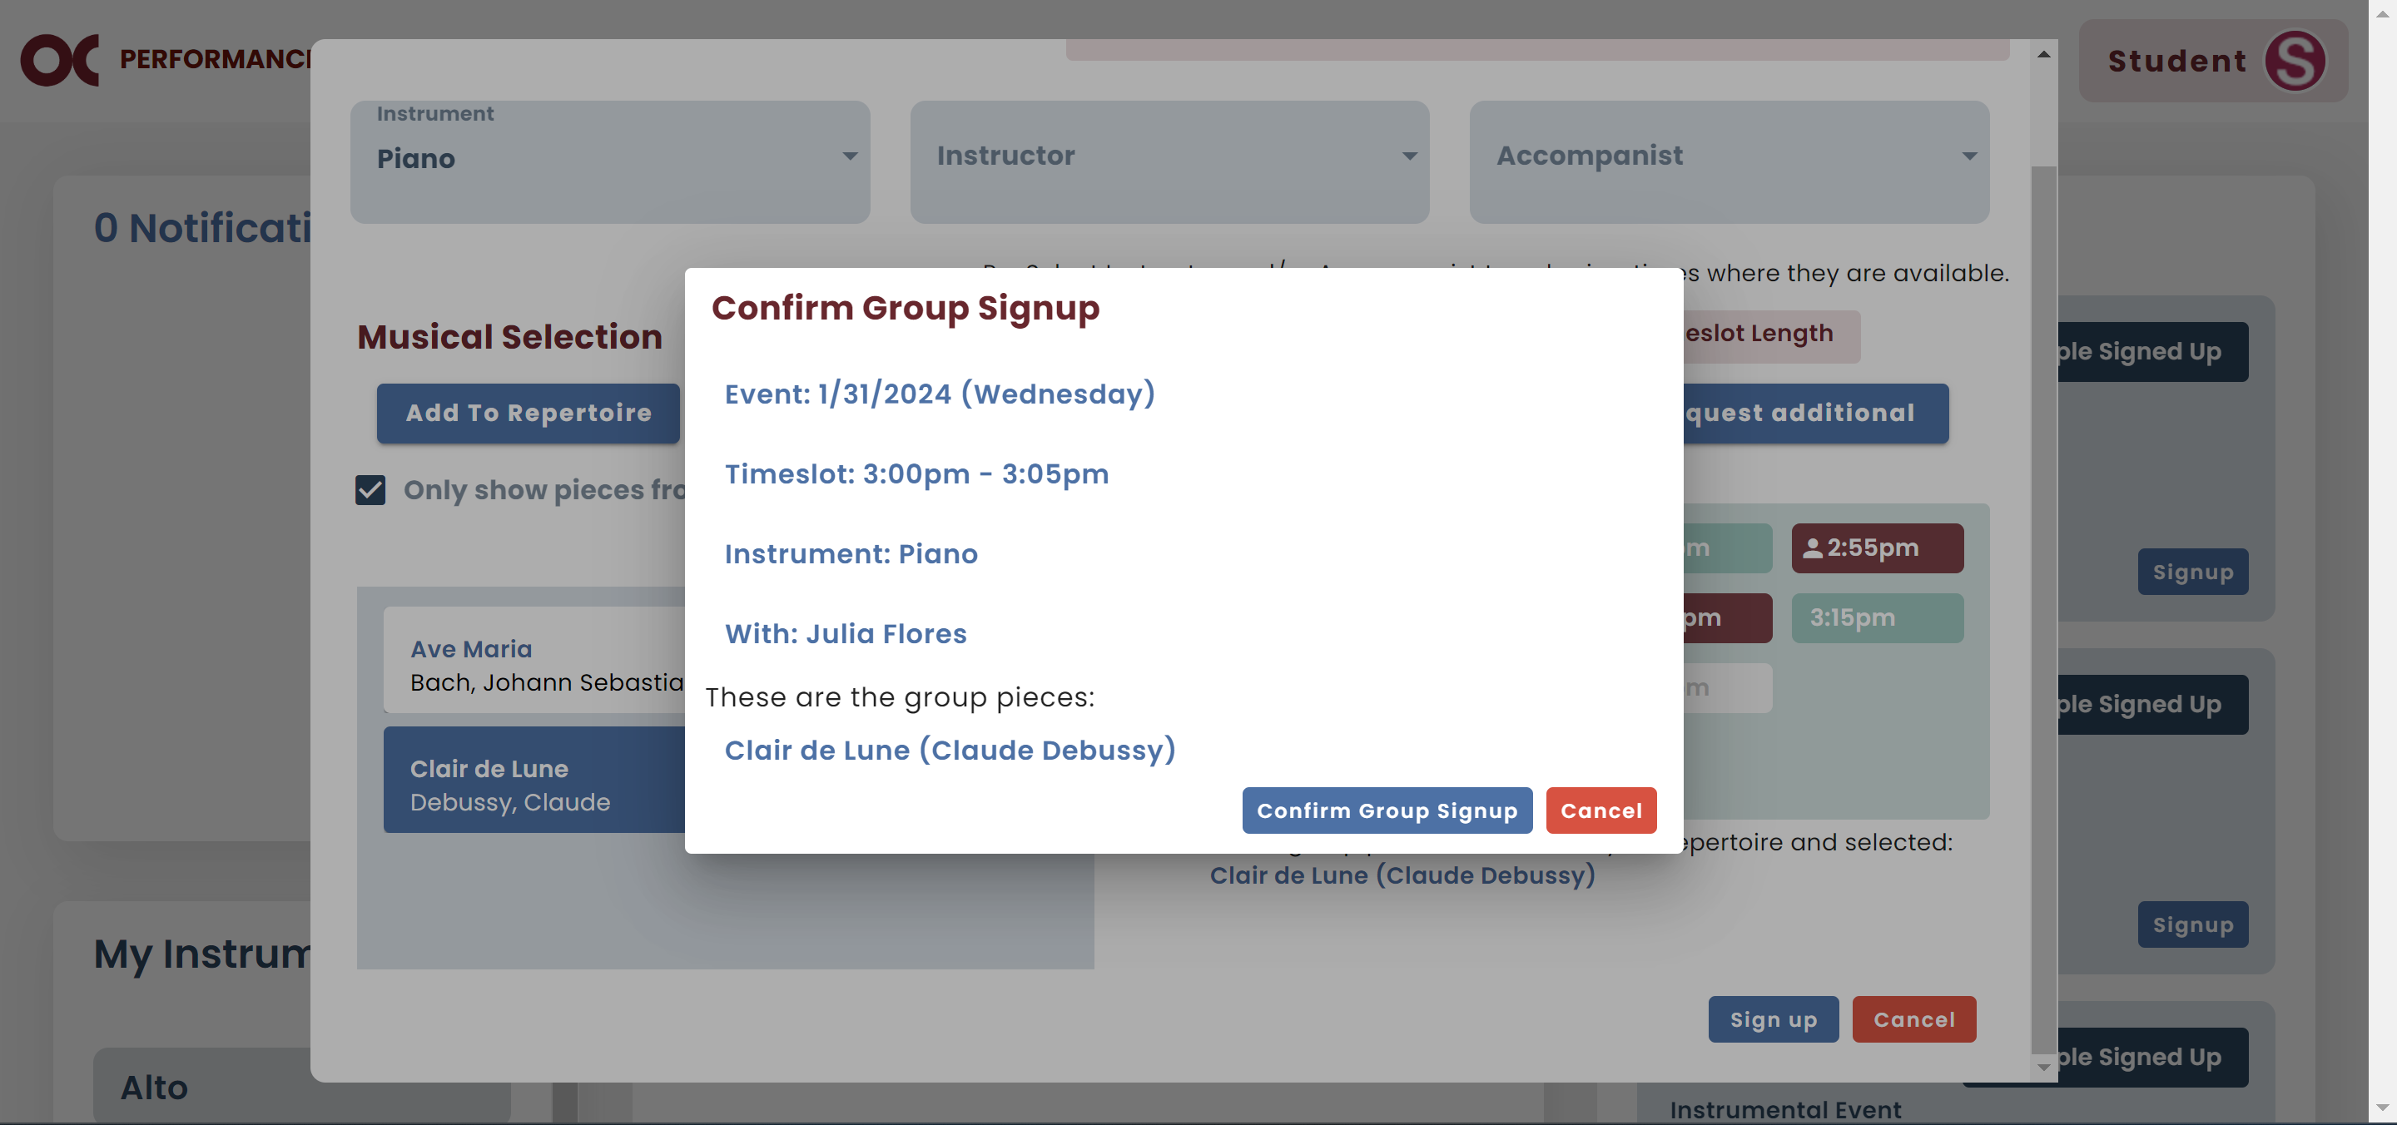

## Request Time Slot

* In case the only time slot you can perform is already occupied by someone, you can send them a request for their slot.
* The person will receive a notification on their home screen and an email.
* If the person can perform in another time slot, they will delete their signup, and sign up for a different time slot.
* **Note:** It is recommended that the student email the requester back to notify them that the requested time slot is now available.
  1. Select your piece.
  2. Select the occupied time slot you want and click Sign up.

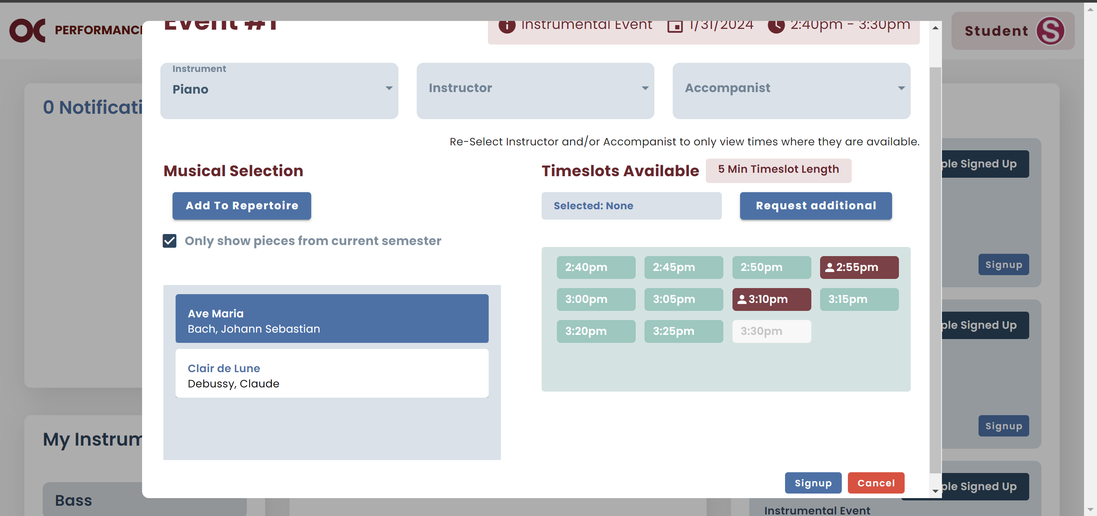

* 1. If that is the desired time slot, click Request This Timeslot.
  2. **Note:** In this message, you will be able to see who the person is you are sending the request for.

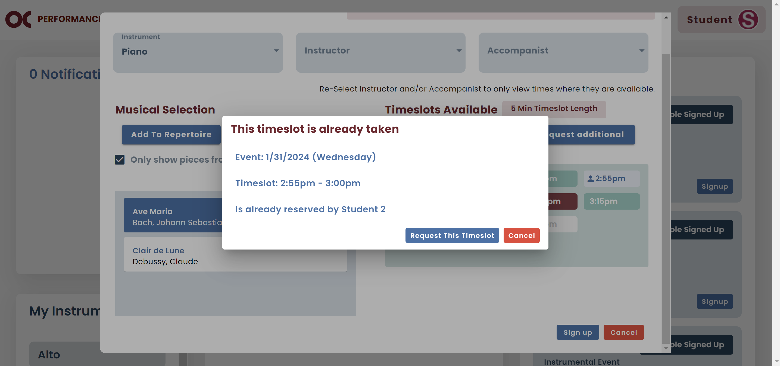

## Request Additional Time Slots

* In case there are no slots that work for you, you can request additional time slots.
* Your request will be sent via email to your instructor, and they will be able to add extra slots.
  1. You will click on Request Additional.

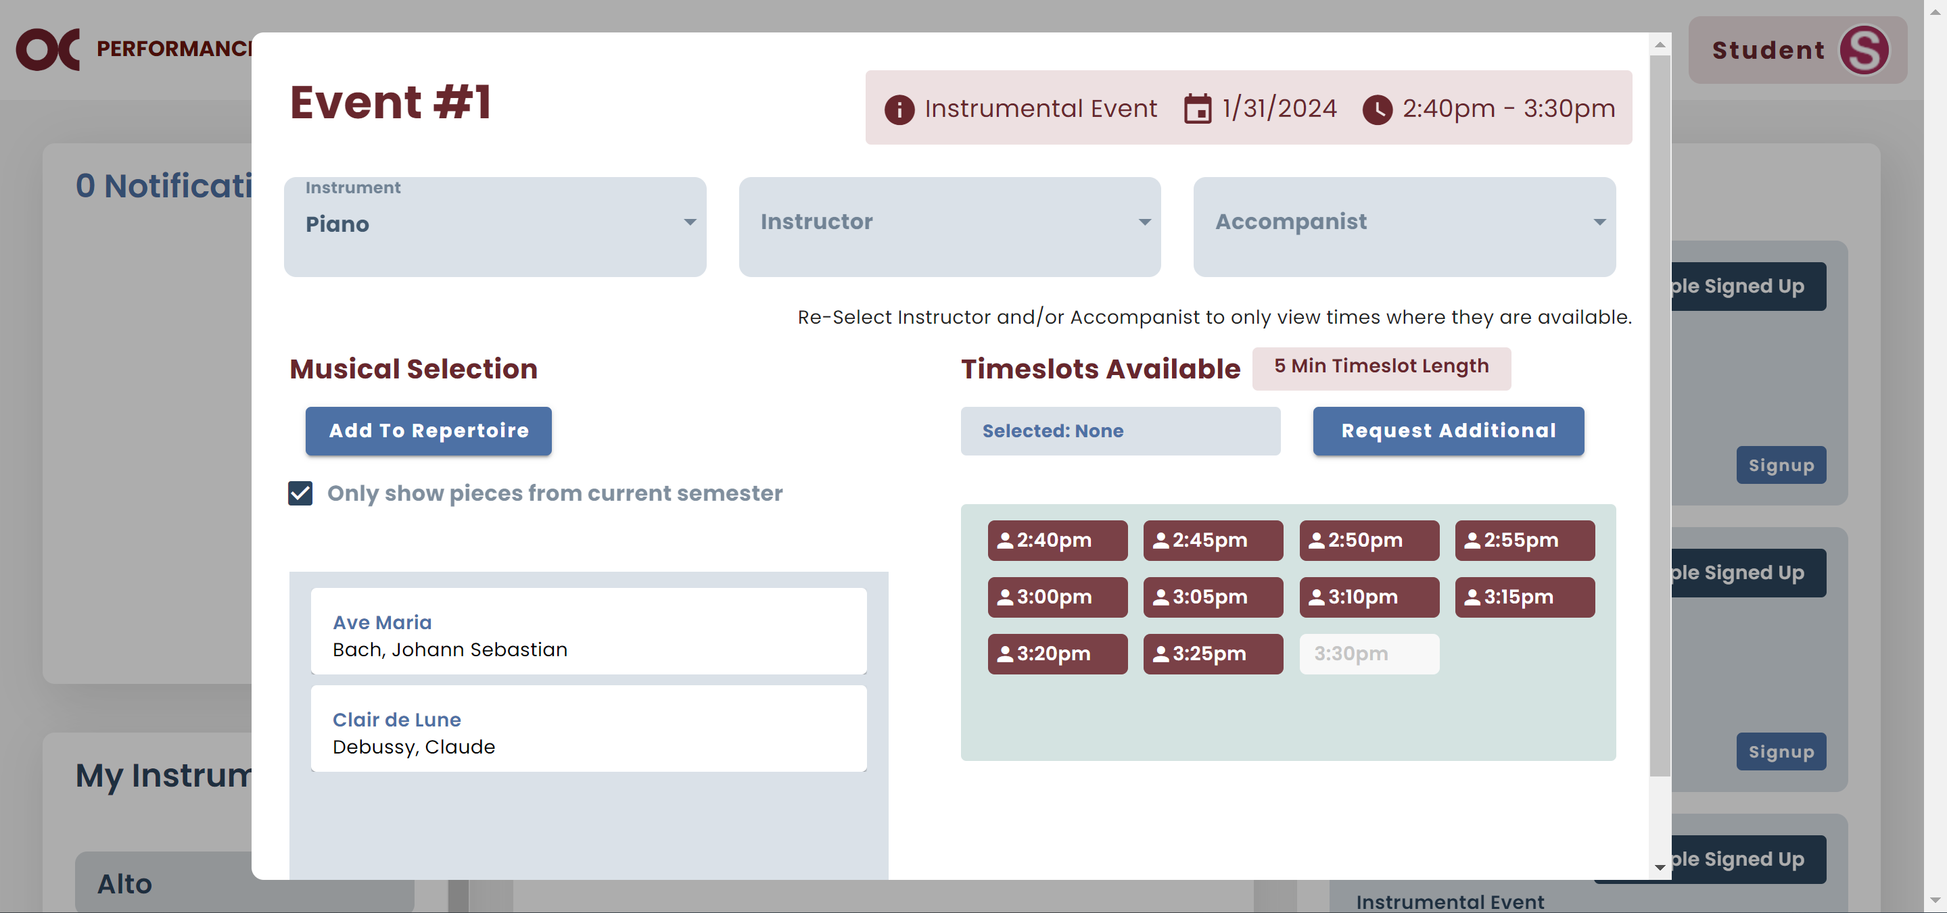

* 1. If you are sure about your request, click Send.

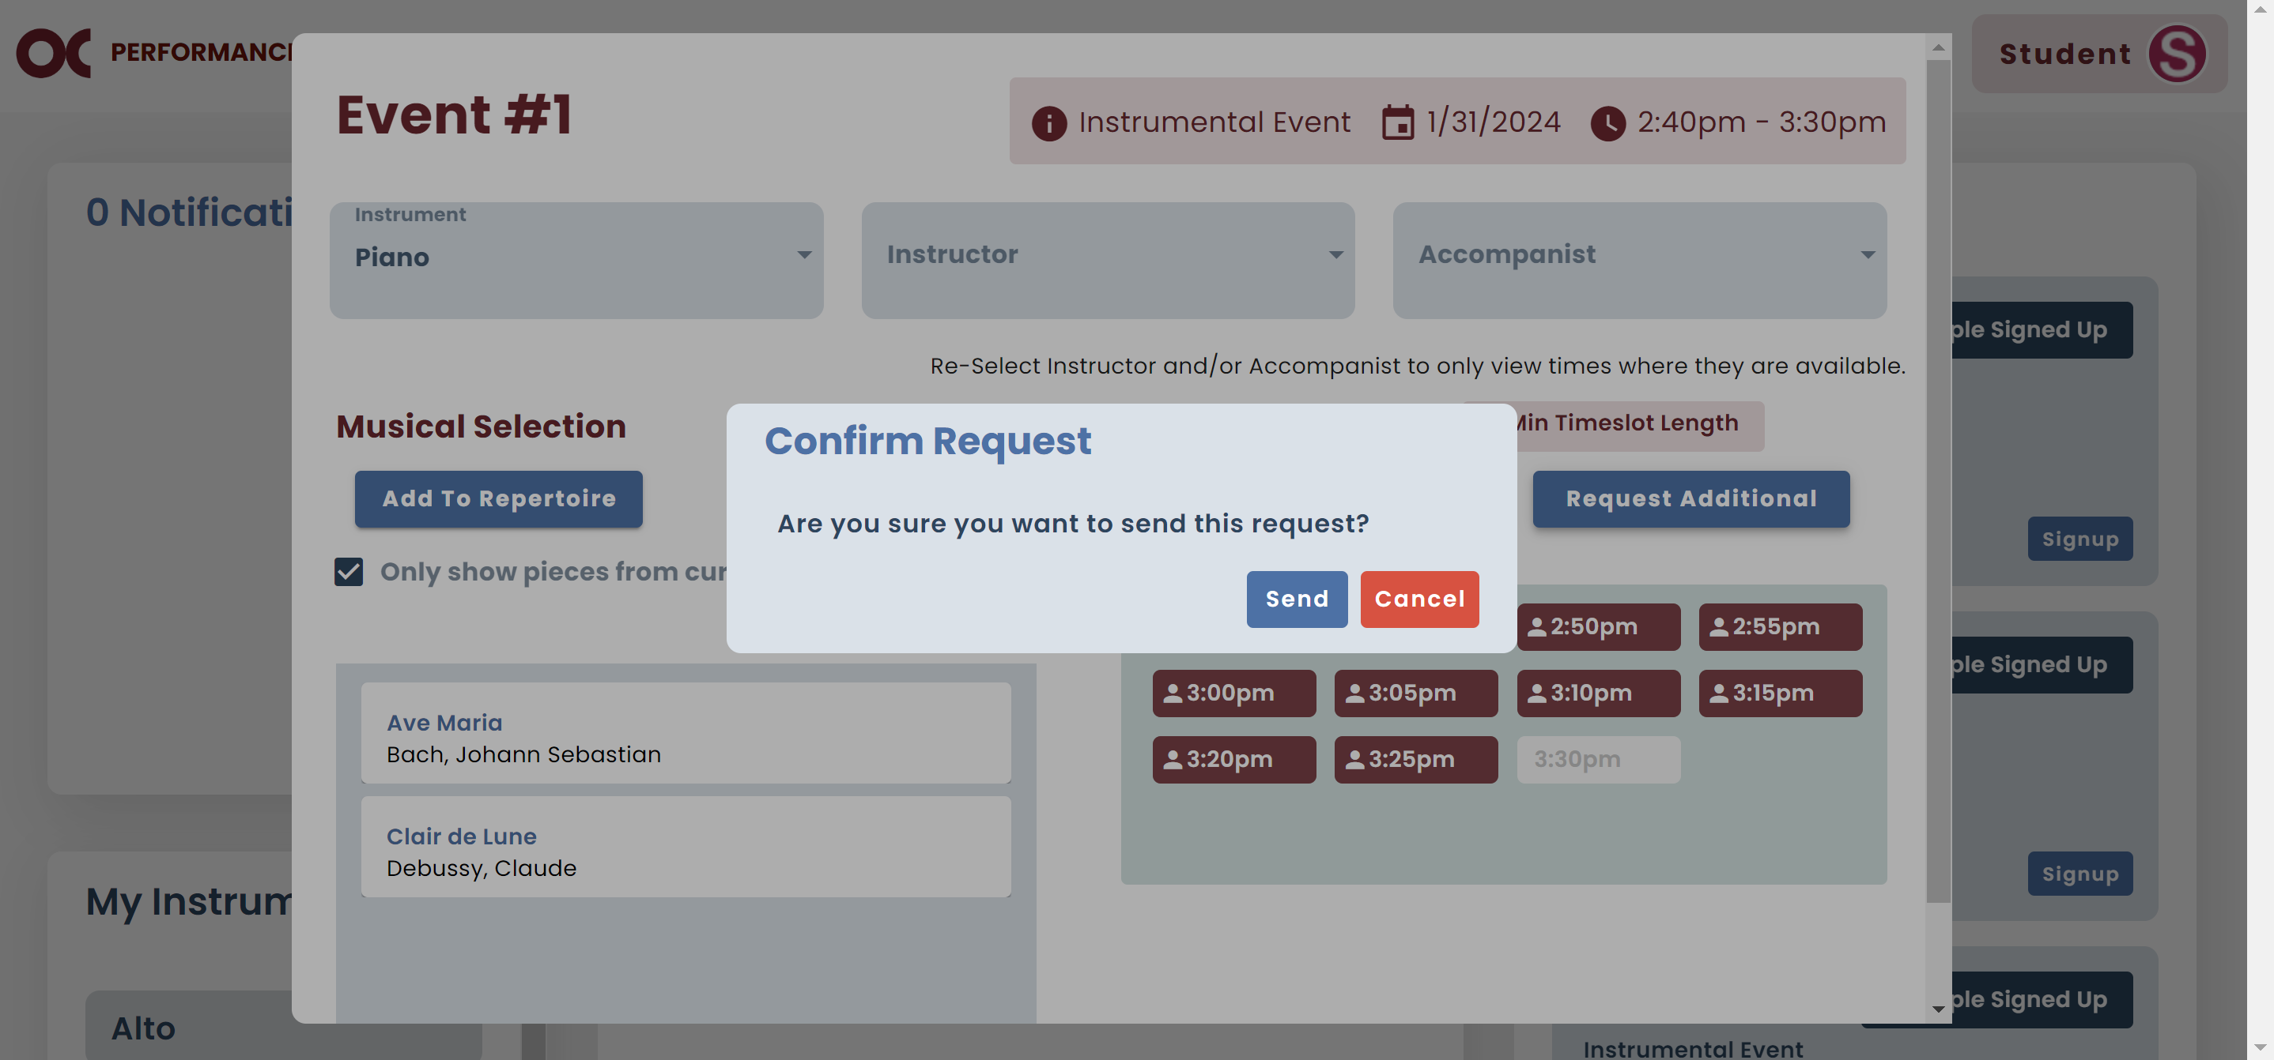

## Request Availability

* In case you need your instructor to be there and they have not entered their availability yet, you can send them a request.
* The same applies for accompanists.
* They will receive an email requesting to set up their availability for that event.
  1. Click on Request Availability.

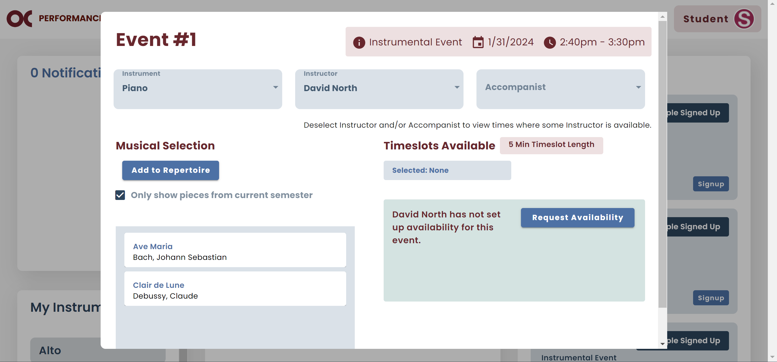

* 1. If you are sure about your request, click Send.

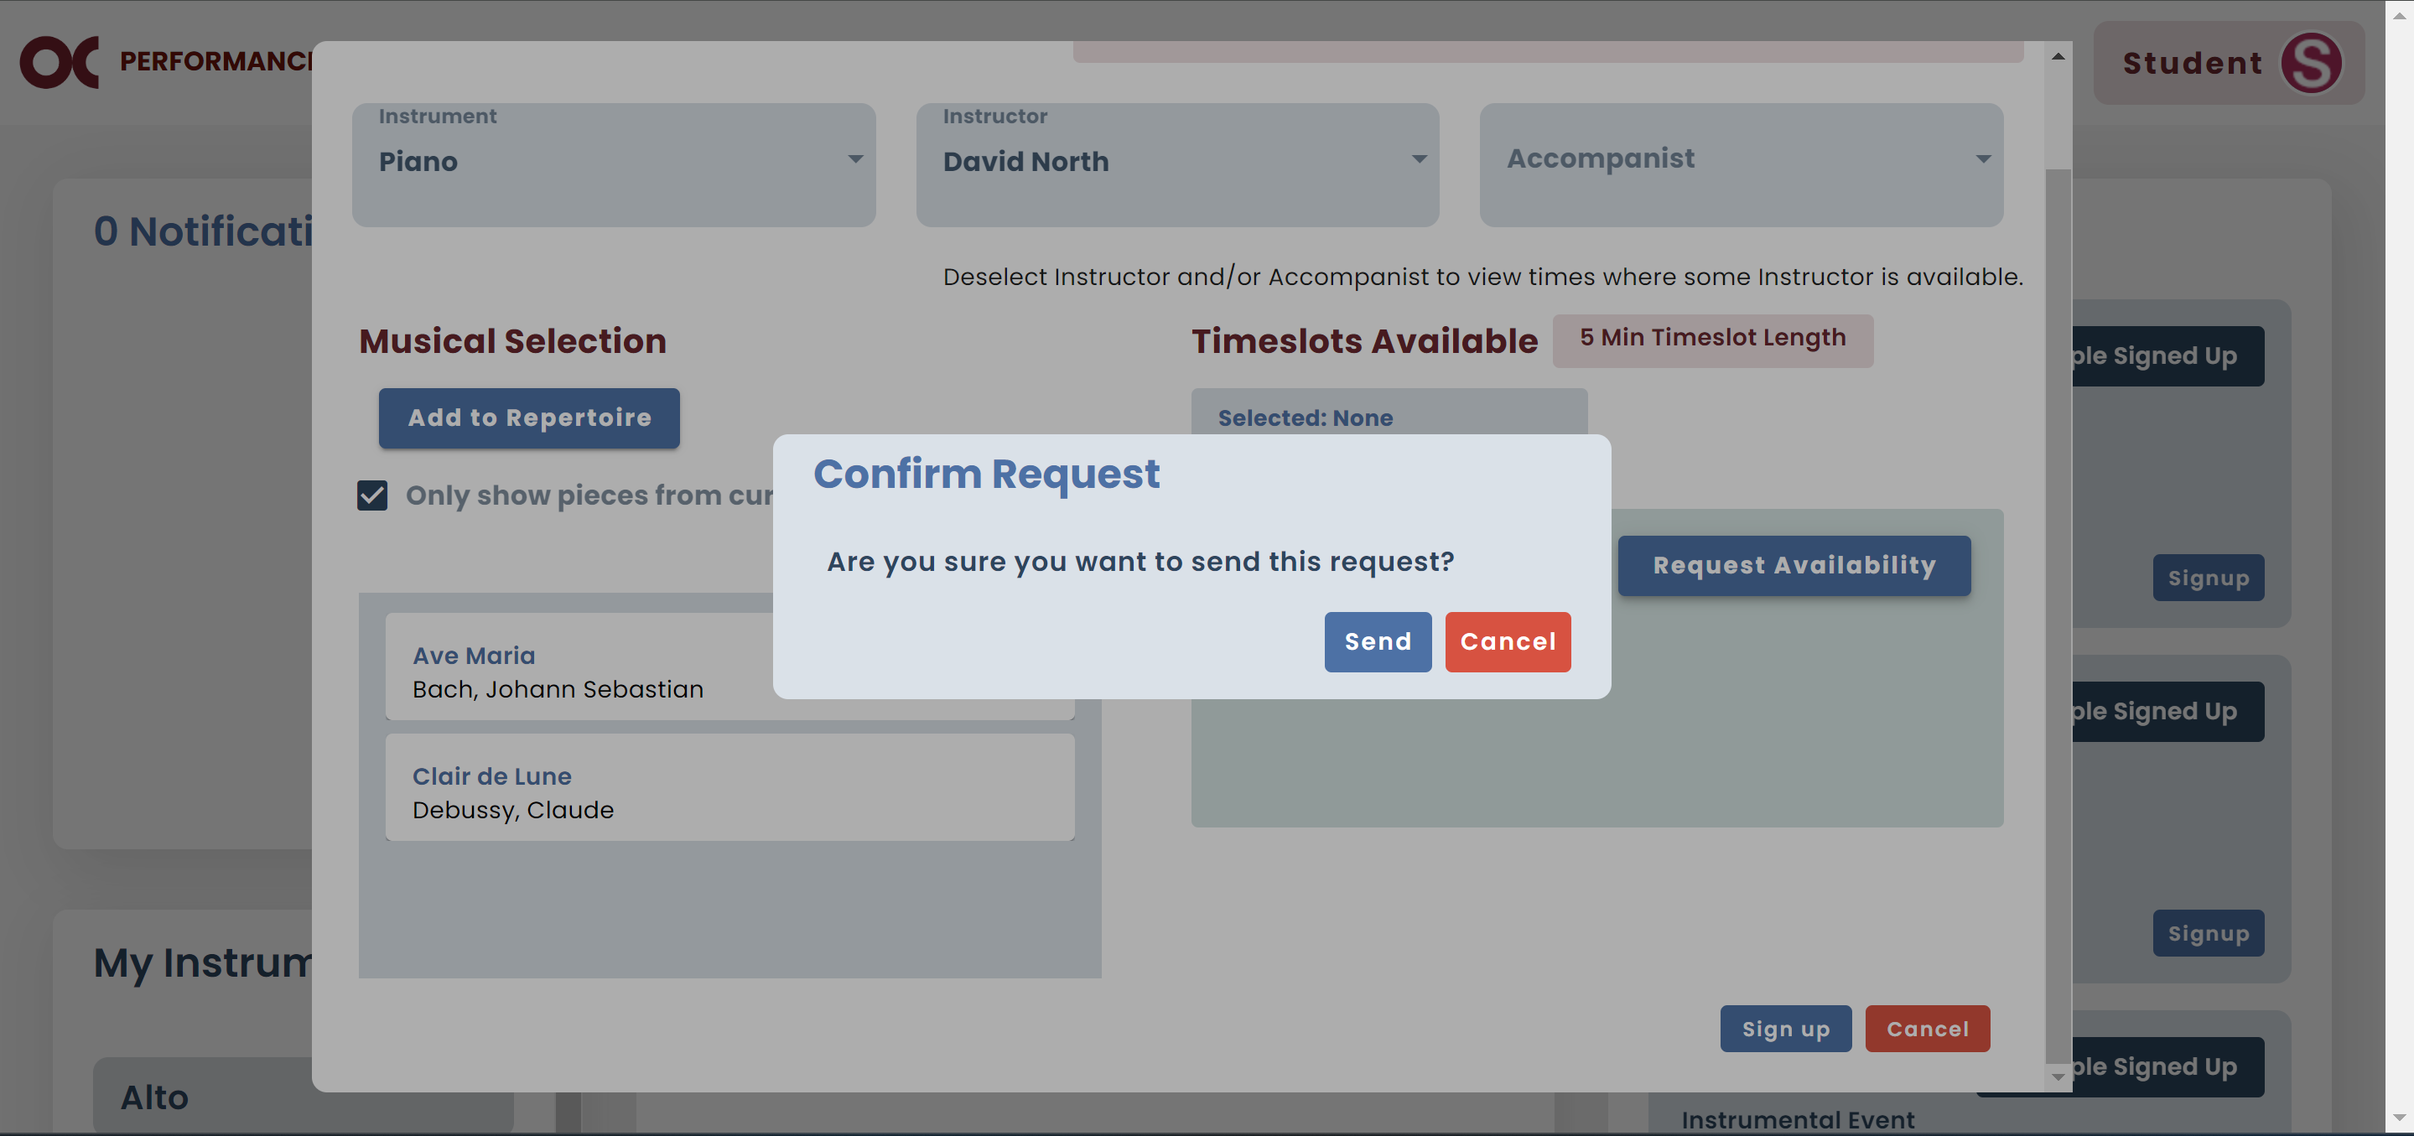

## Edit Signup

* If you want to update the information, go to the Events I’m Signed up For column and click Edit Signup.

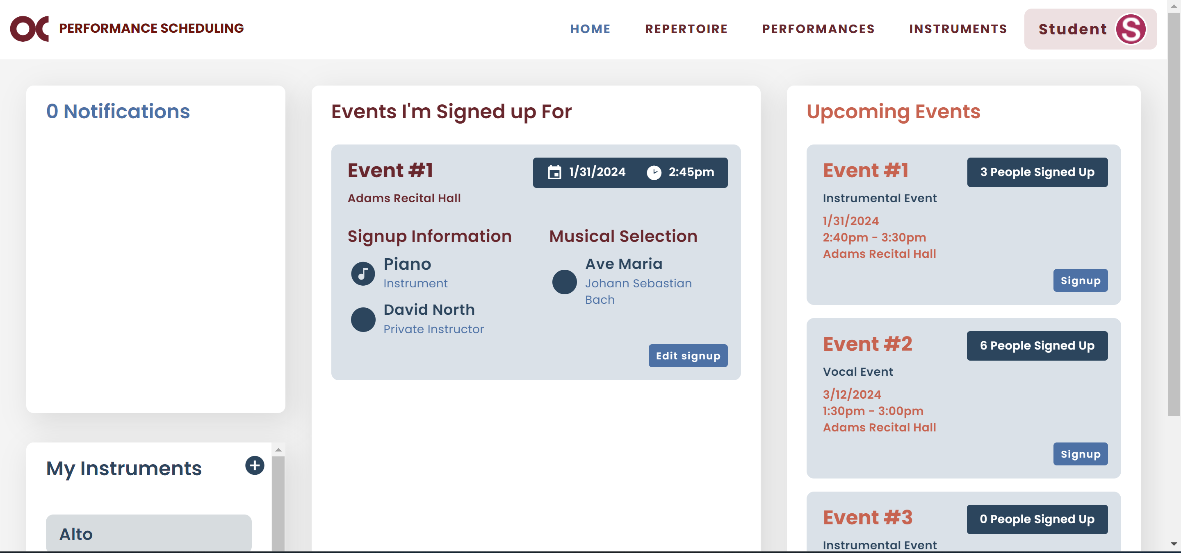

* You can edit the pieces you will perform or allow other students to perform with you. Once that is done, click Save.

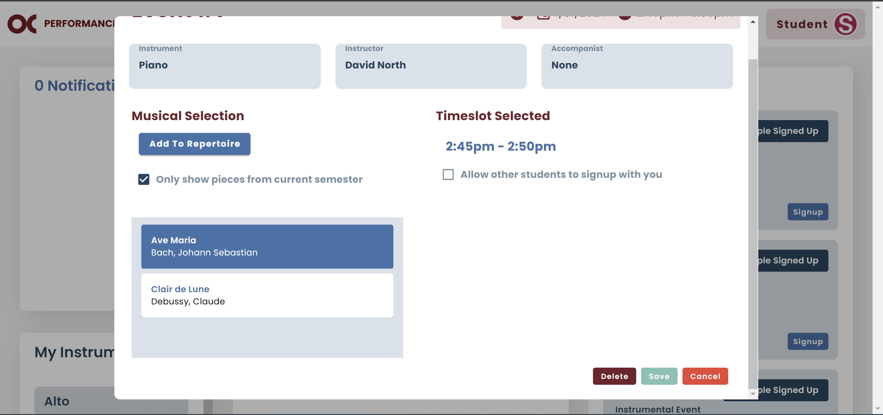

## Delete Signup

* If you cannot perform on the time slot you are currently signed up for, you can delete it.
  1. In the same dialog you edit your time slot**,** select Delete.



* 1. If you are sure you want to proceed with the deletion, click Confirm.

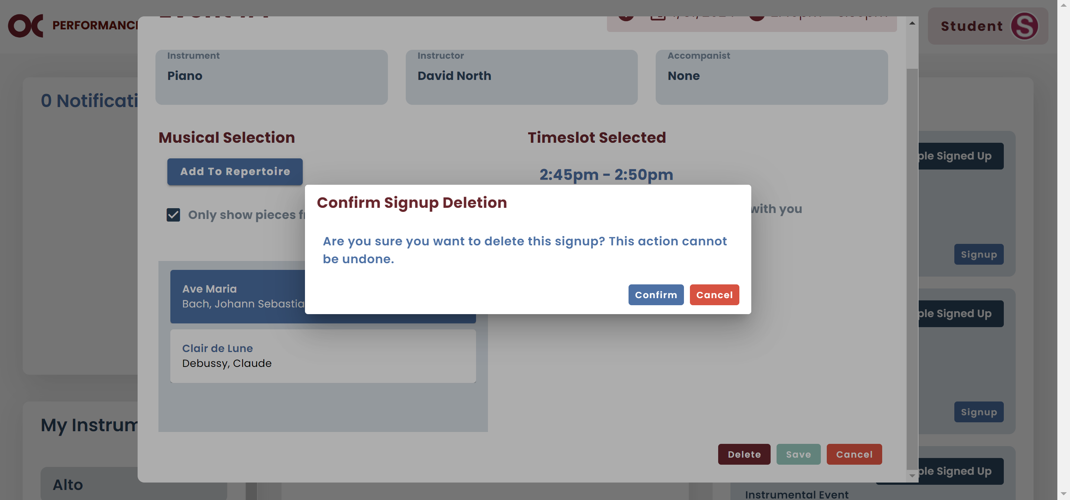

# Performances

* You can check your previous performances information by selecting Performances.

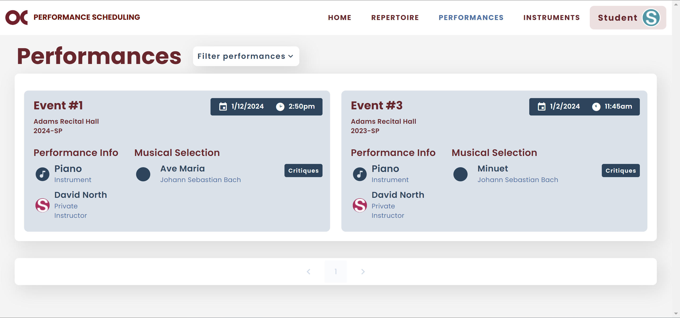

* You can check the critiques for a specific event.
  1. Find the performance you want.
  2. You can filter them by semester and/or instrument. You must select your option and click “Apply Filter”.

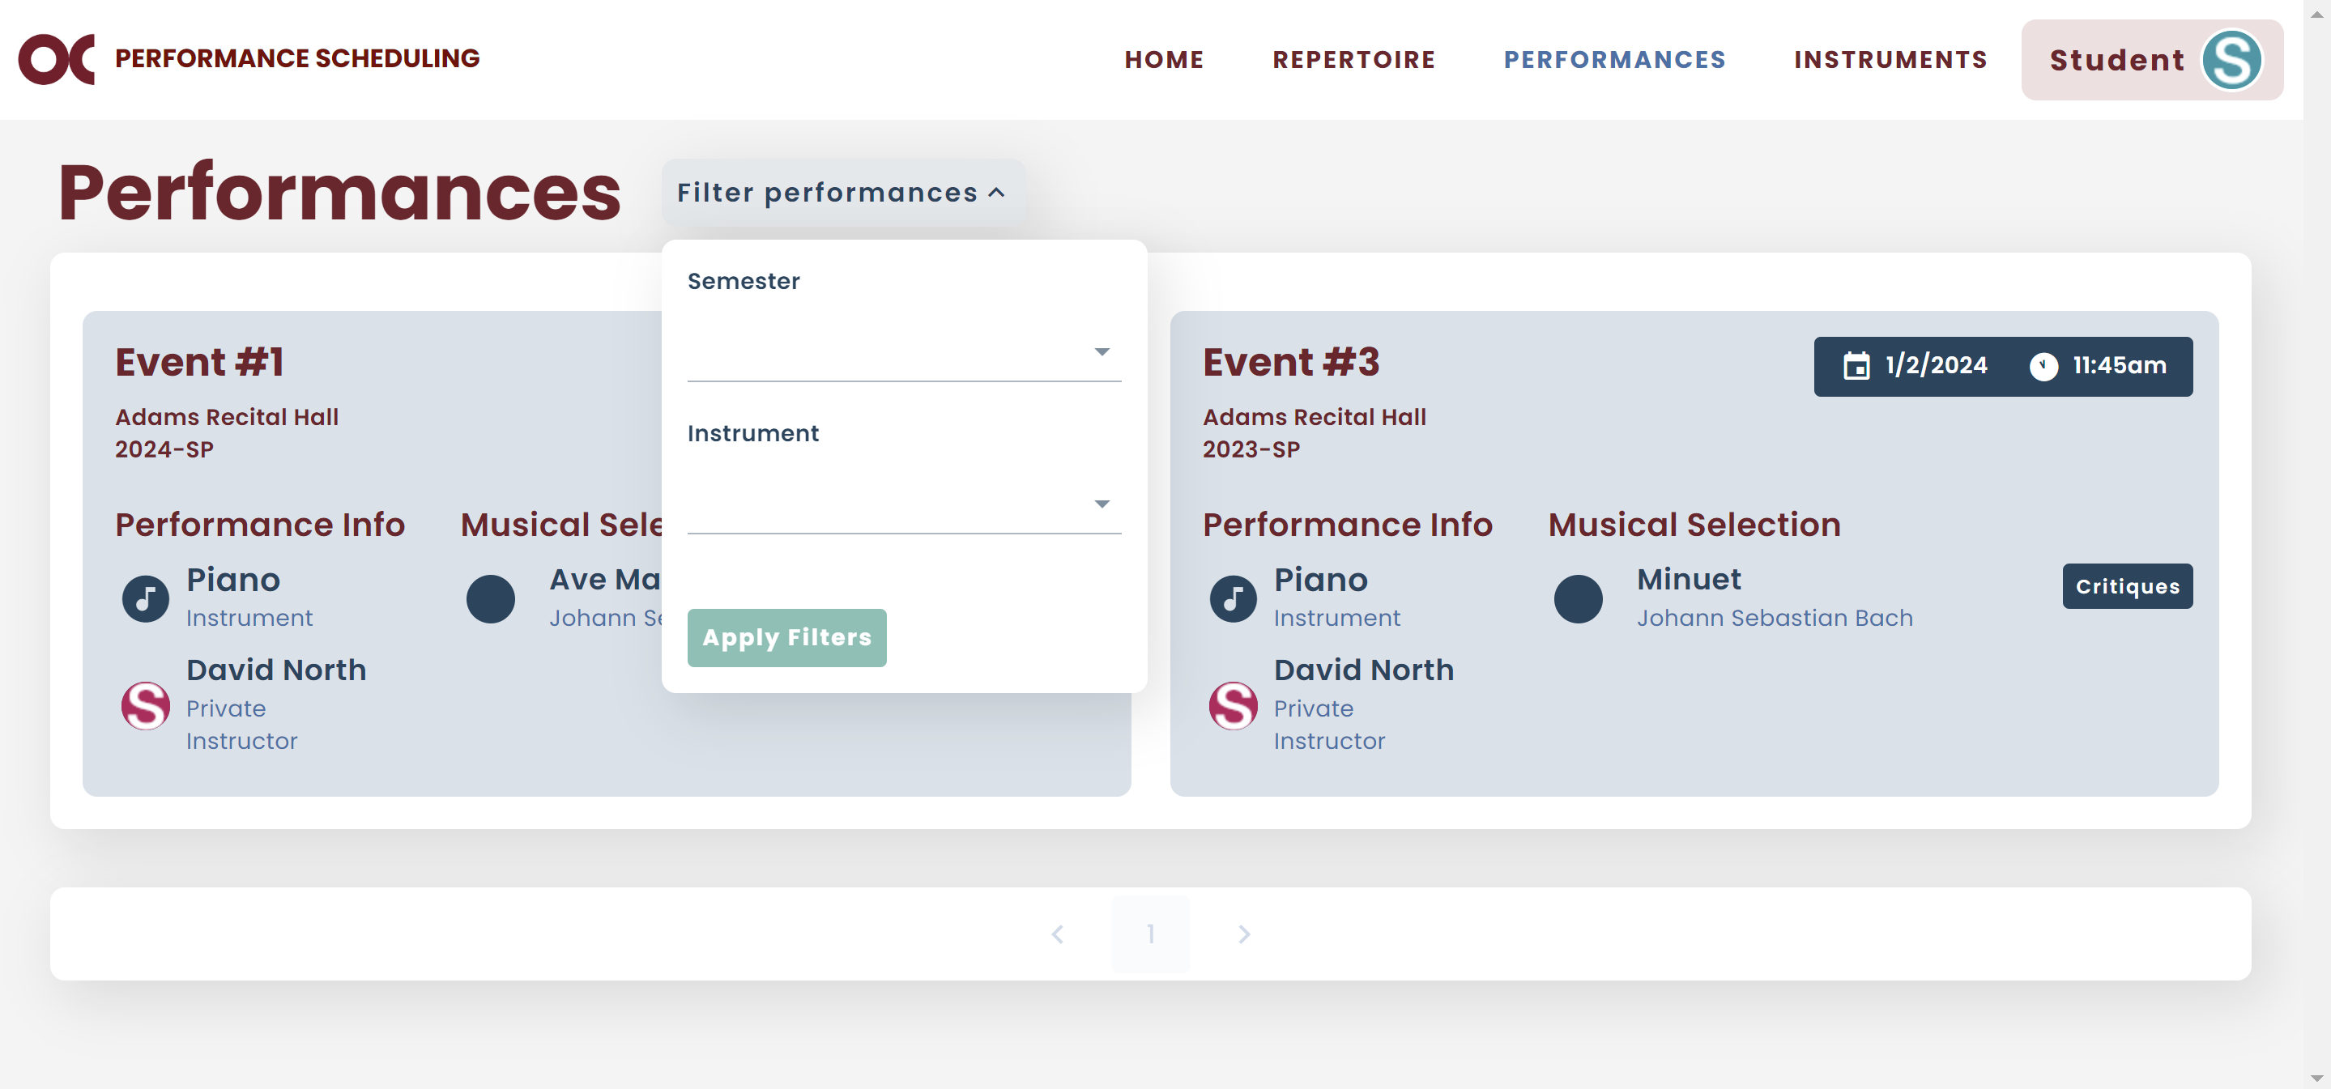

* 1. If you do not want to use the filter anymore, click Clear Filters.

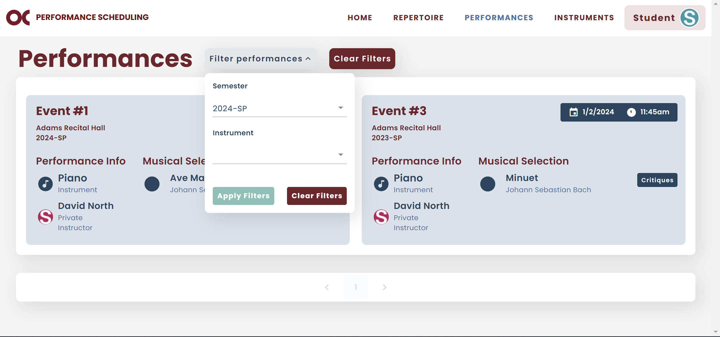

* 1. If you want to view your critiques for a specific performance, select Critiques.



* 1. You will see a list of all instructors that critiqued your performance.

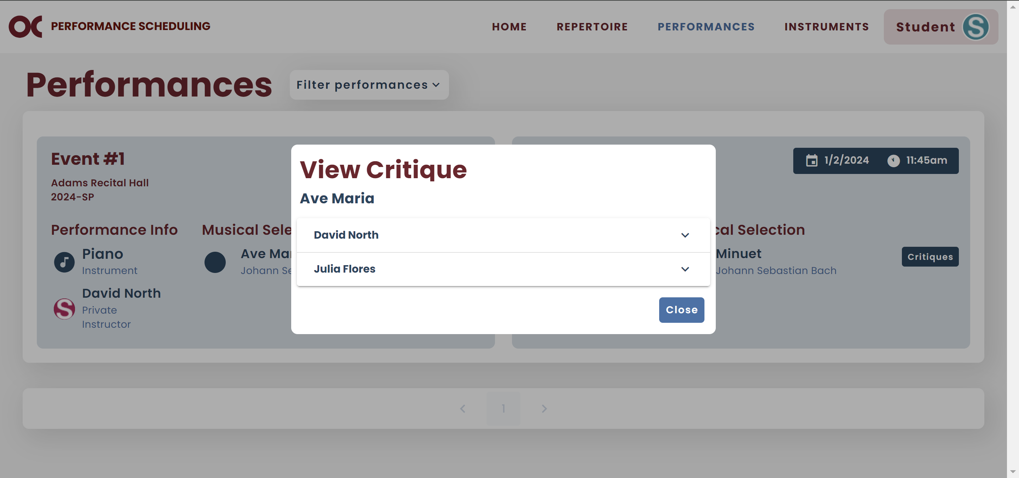

* 1. Select the instructor that you want to view the critiques.

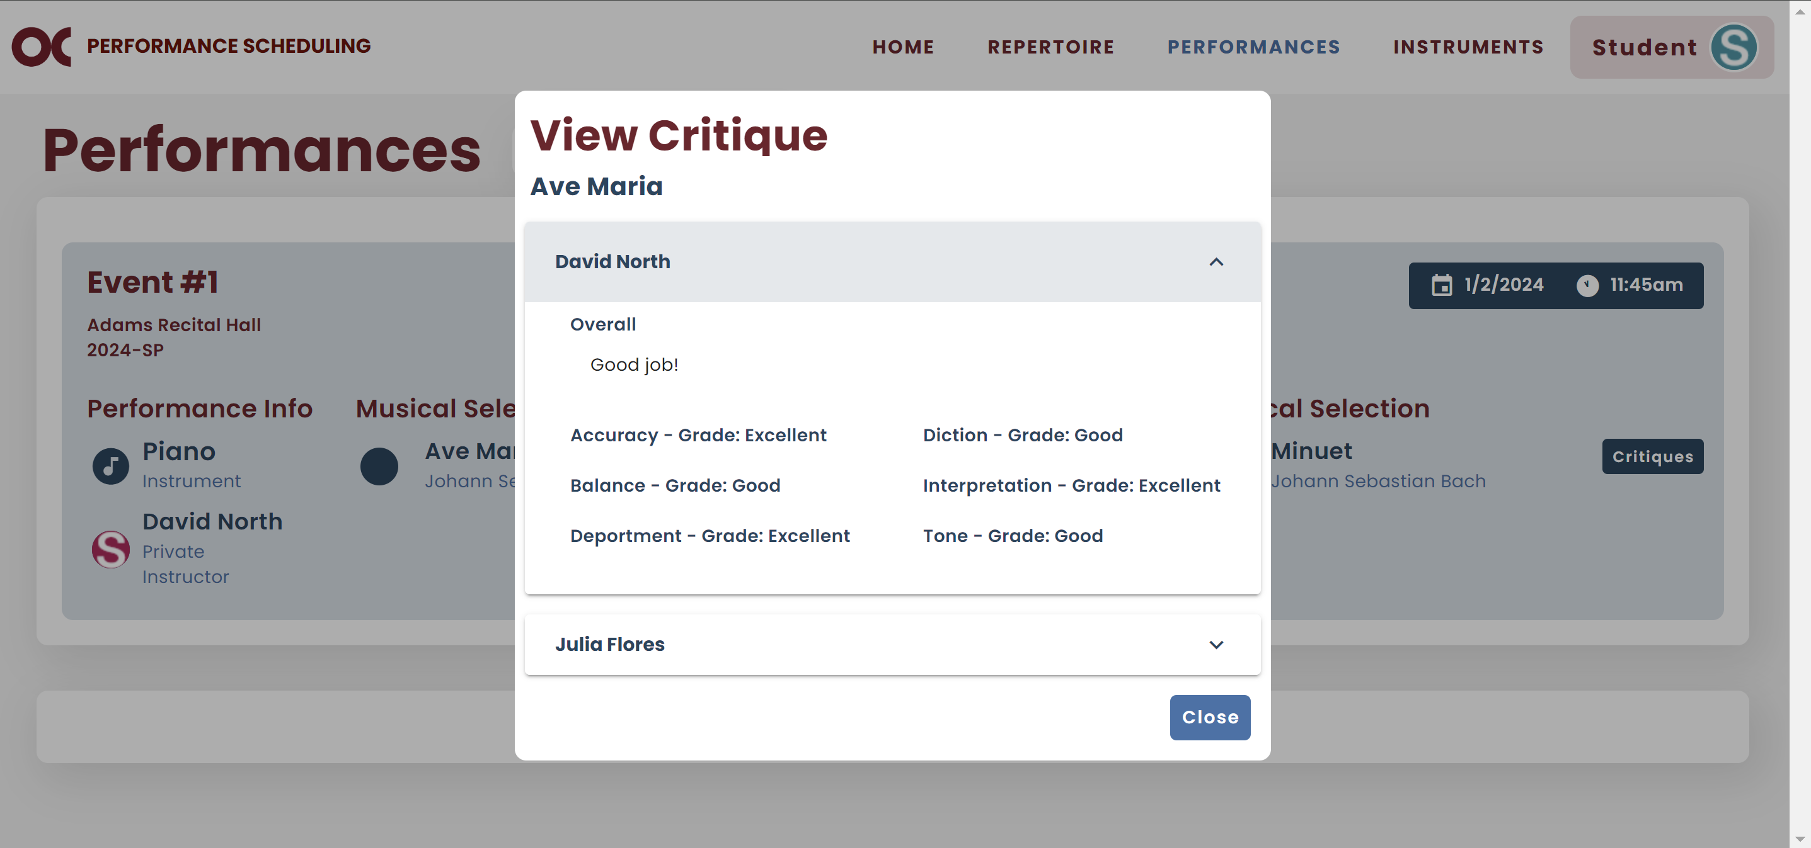

# Instruments

* You can view all your instruments on your Instruments screen.

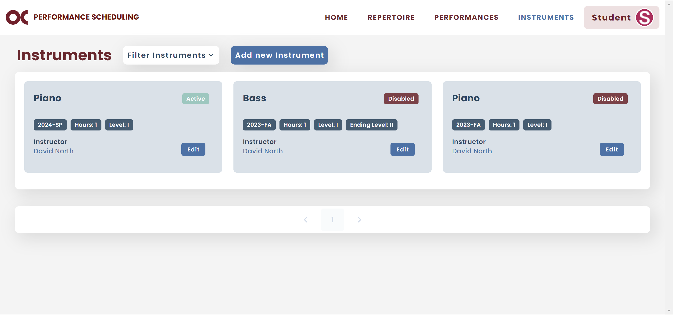

* Your previous semester instruments should be Disabled and your current ones Active.
* You can filter them by status or semester.

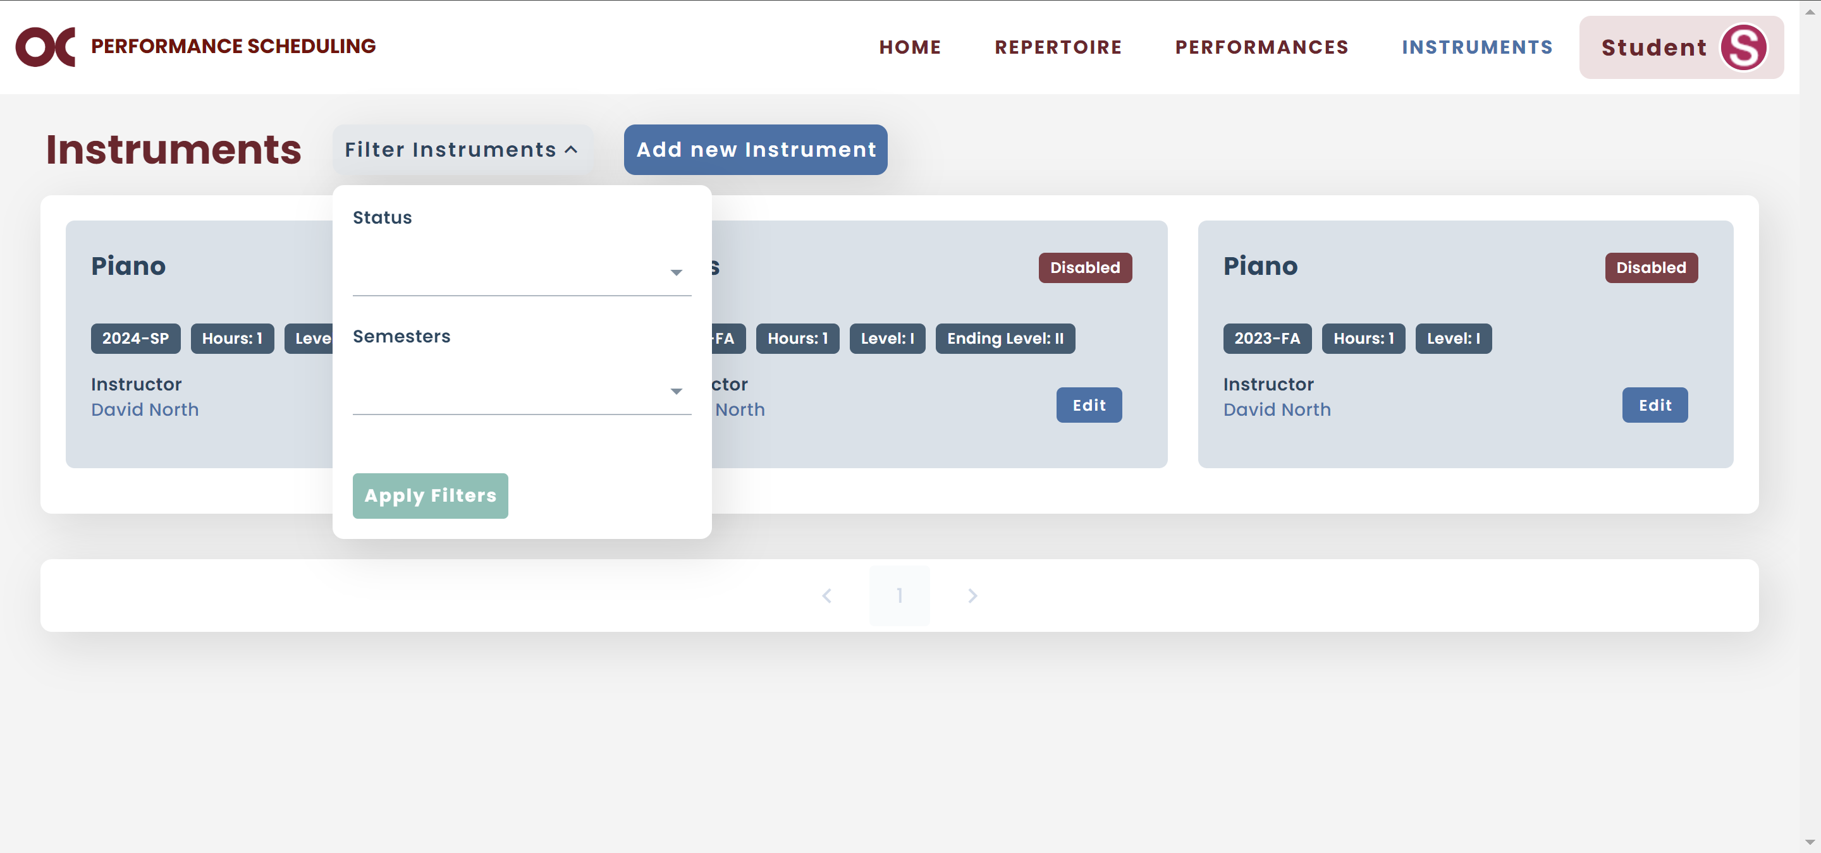

* If you want to add a new instrument, click Add new Instrument.



* 1. To add a new instrument, you first have to select which instrument.
  2. The semester will default for the current one.
  3. If it is an instrument that you already had for previous semesters, the information will automatically be filled out.
  4. If not, select who will be your private instructor.
  5. If you have an accompanist, select your accompanist.
  6. If it is your first time selecting this instrument, your starting level will default to I. If you had selected this instrument previously, it will default to your ending level from your most recent semester.
  7. Add how many credit hours per week you are taking private lessons (should be 1 or 2).
  8. Once all the information is completed, click Add.

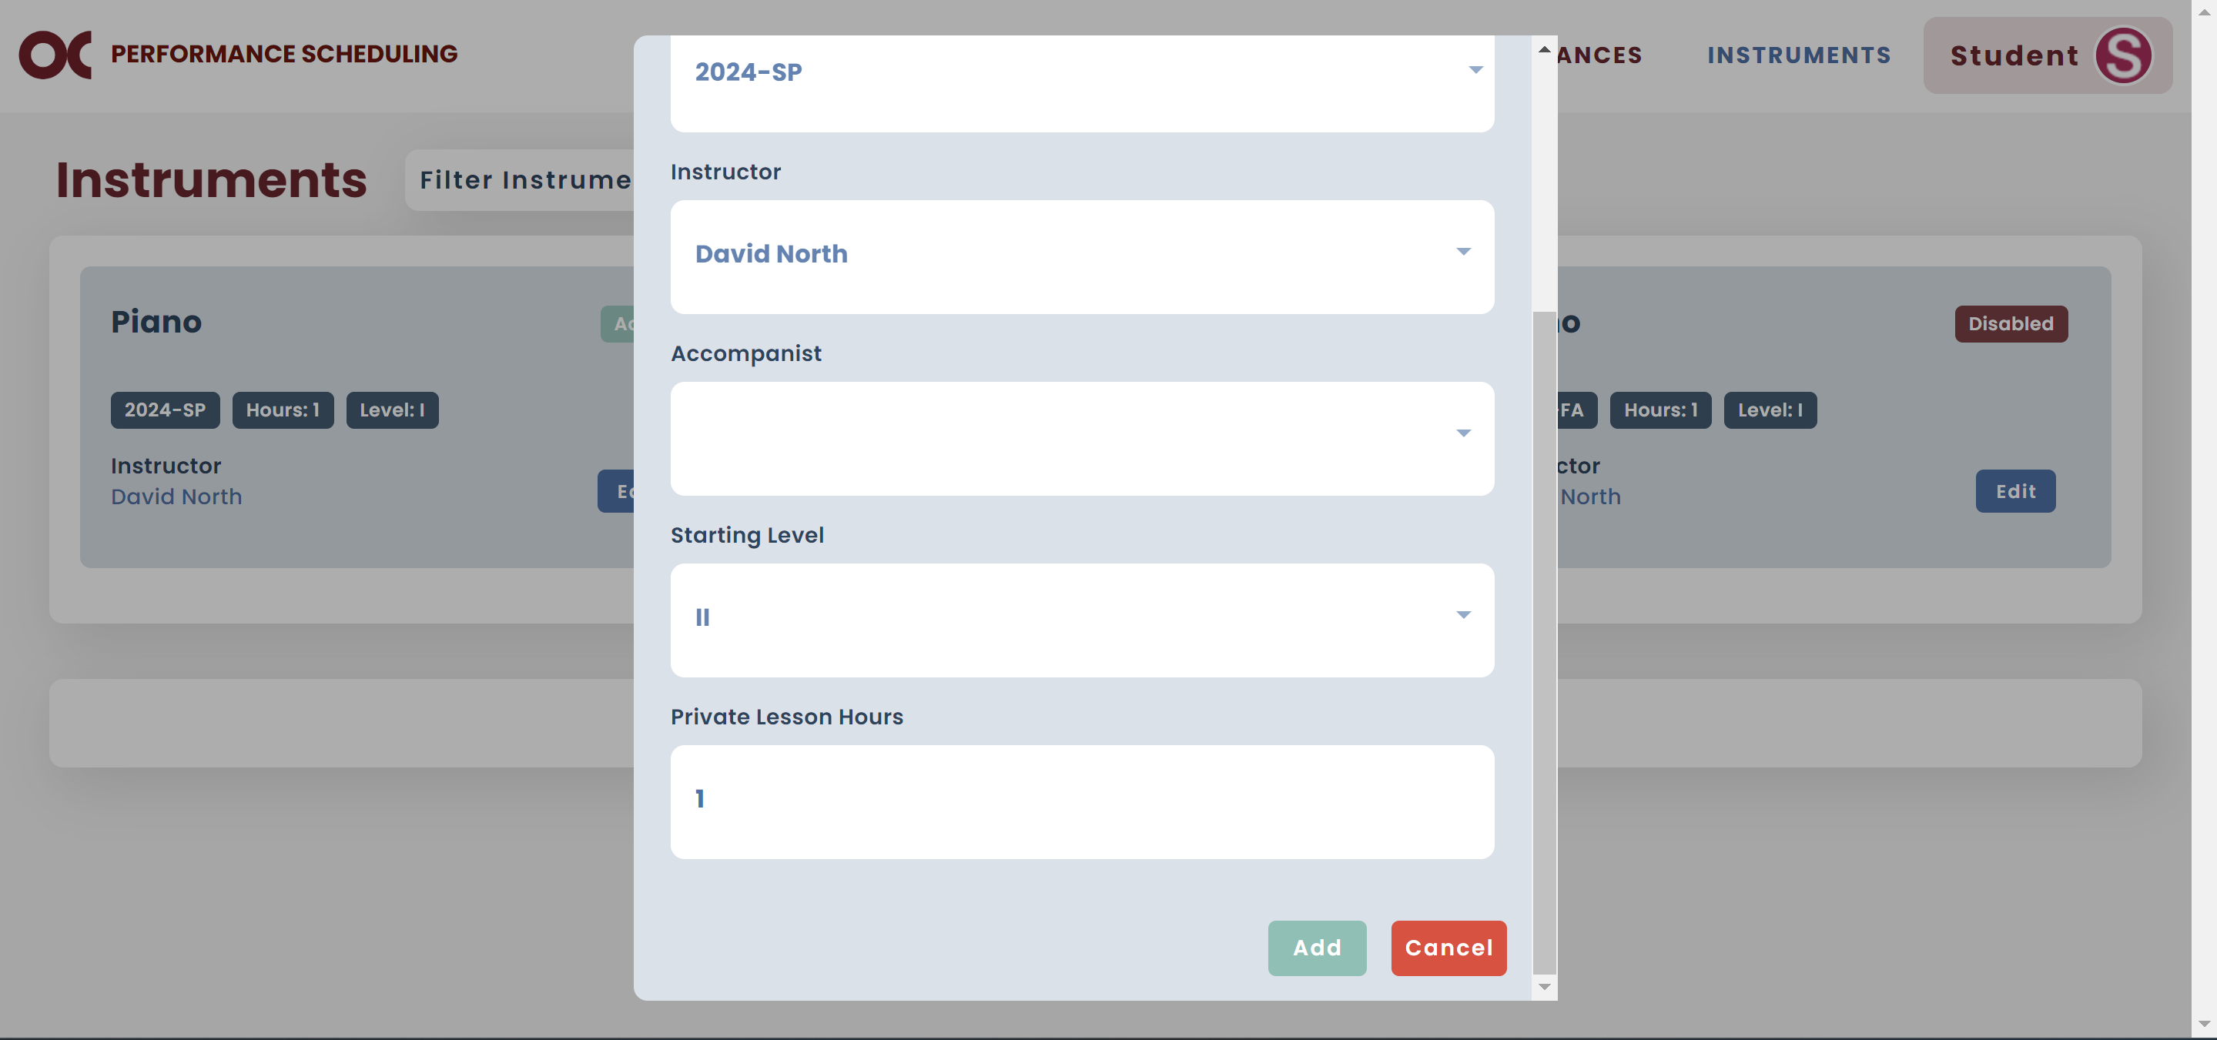

* 1. Now your new instrument is added to your profile.

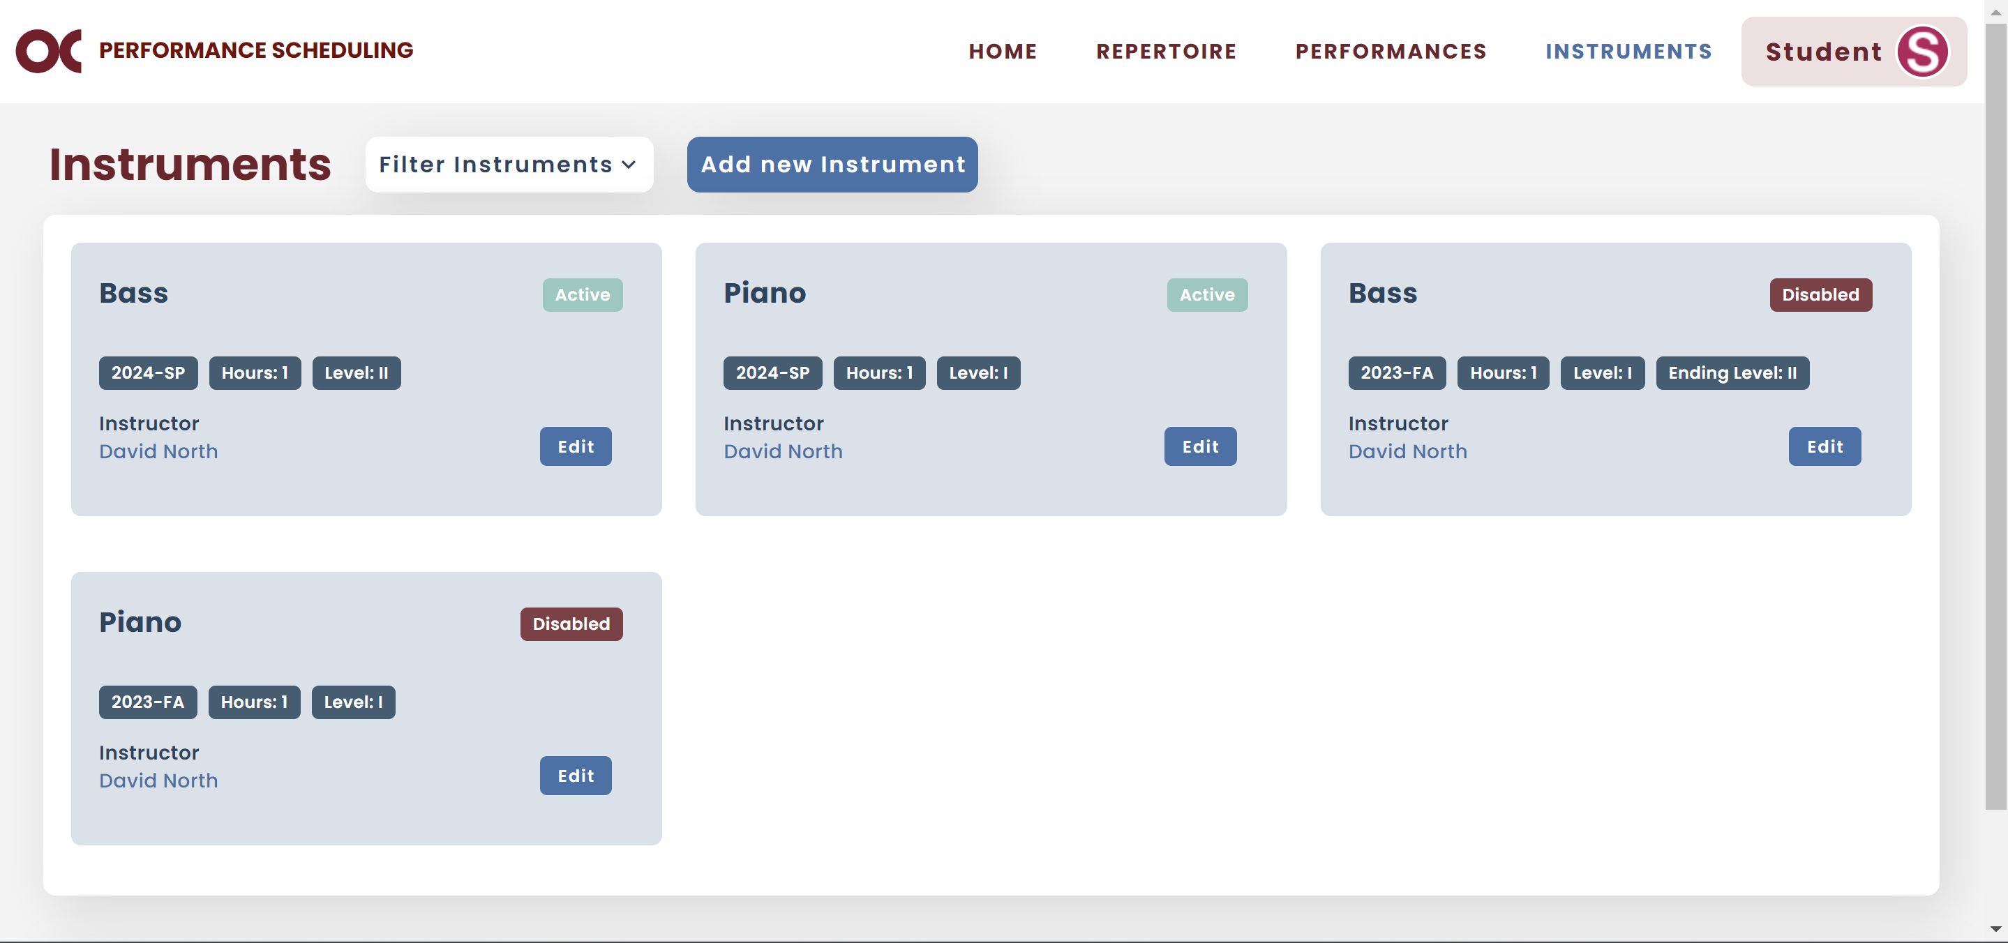

# Repertoire

* You can view all your pieces on your Repertoire screen.

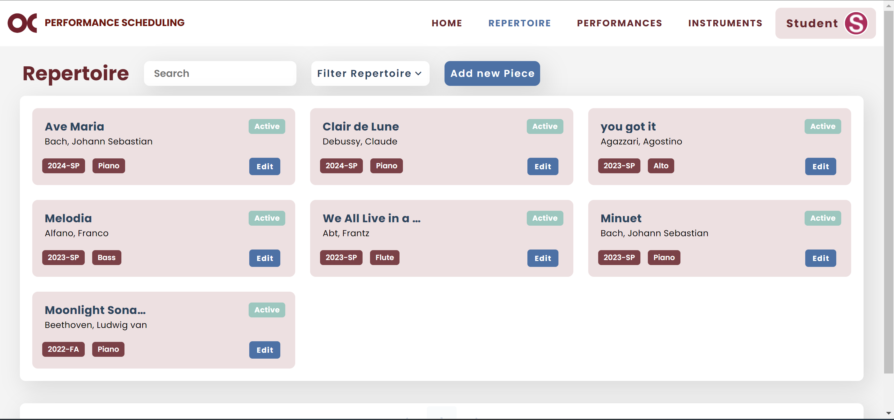

* You can filter them by status or semester, or search for a specific one.

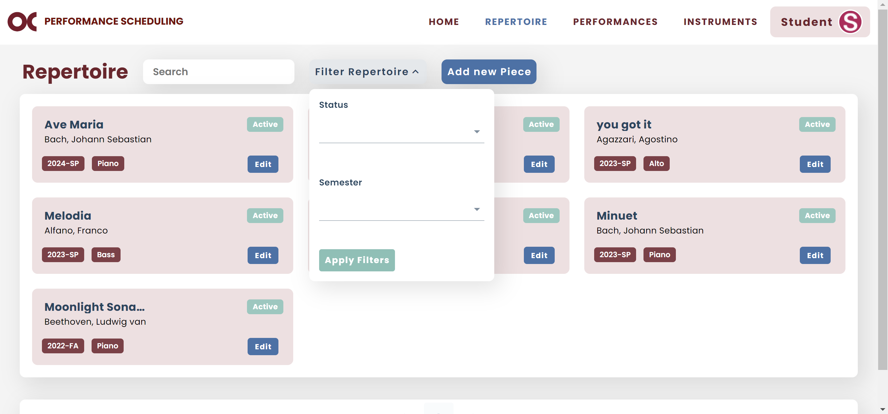

* If you want to add a new piece to your repertoire, click Add new Piece.



* 1. To add a new piece, you first have to select your instrument.
  2. Type the name of the composer.
  3. If you cannot find the composer, click Add Composer.

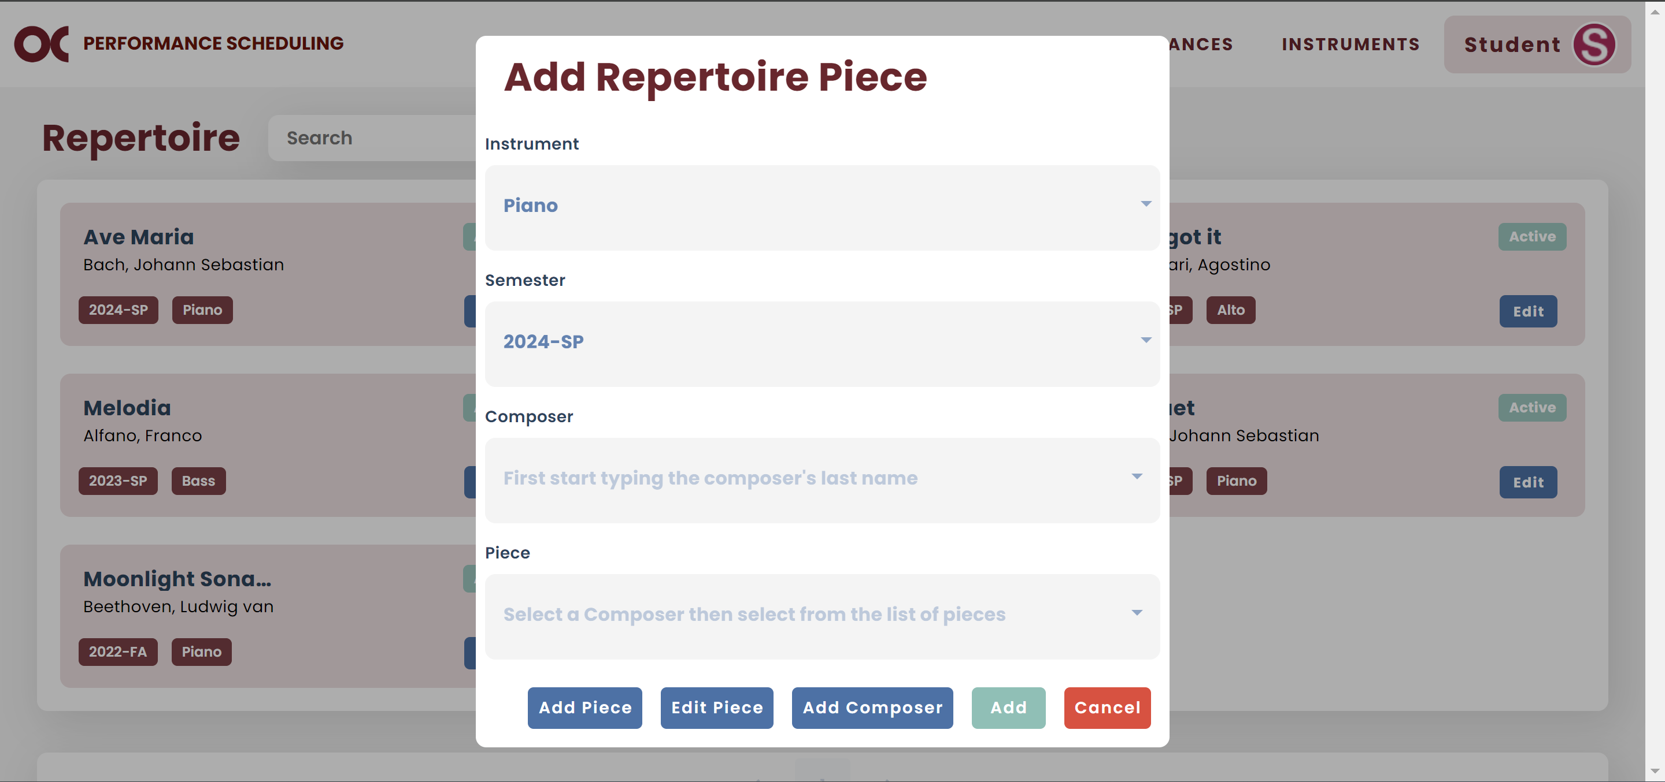

* 1. Type the proper information and click Add.

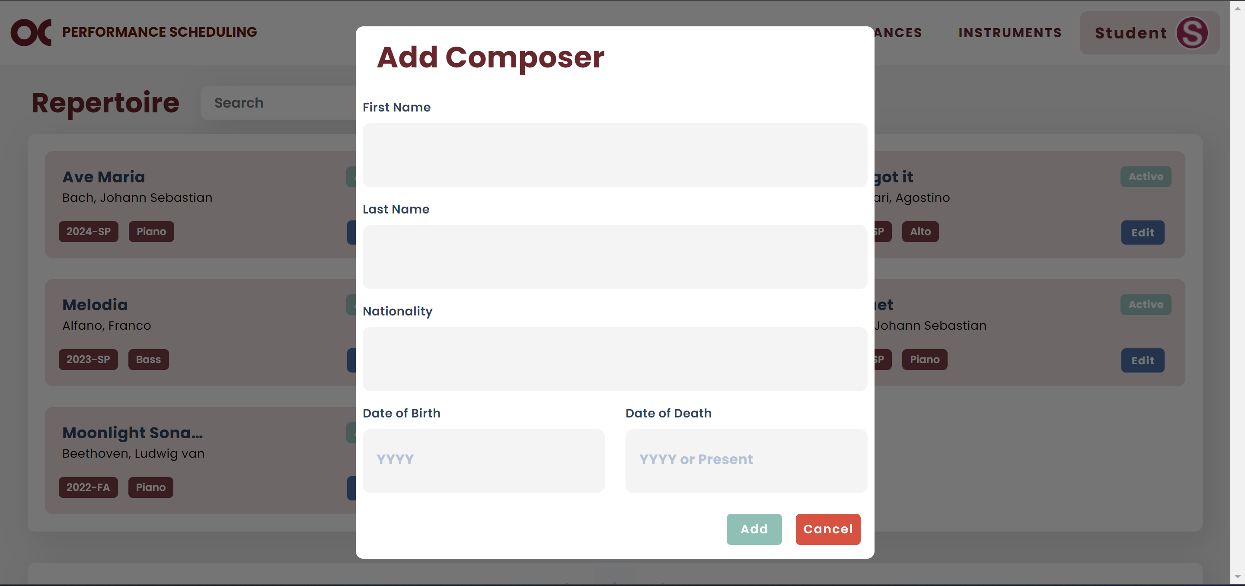

* 1. Now you can type the name of your composer and it will show in the list.
  2. After selecting your composer, select the piece.
  3. If you cannot find it, click Add Piece.

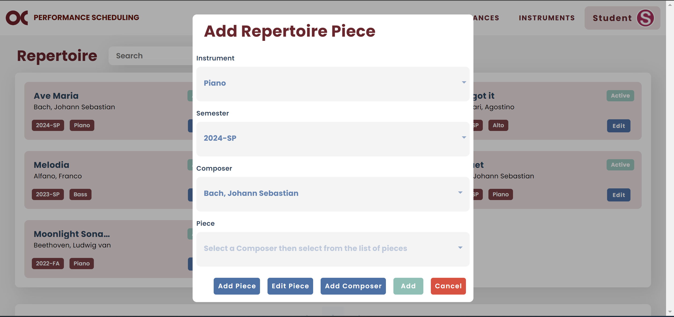

* 1. Type the proper information and click Add.

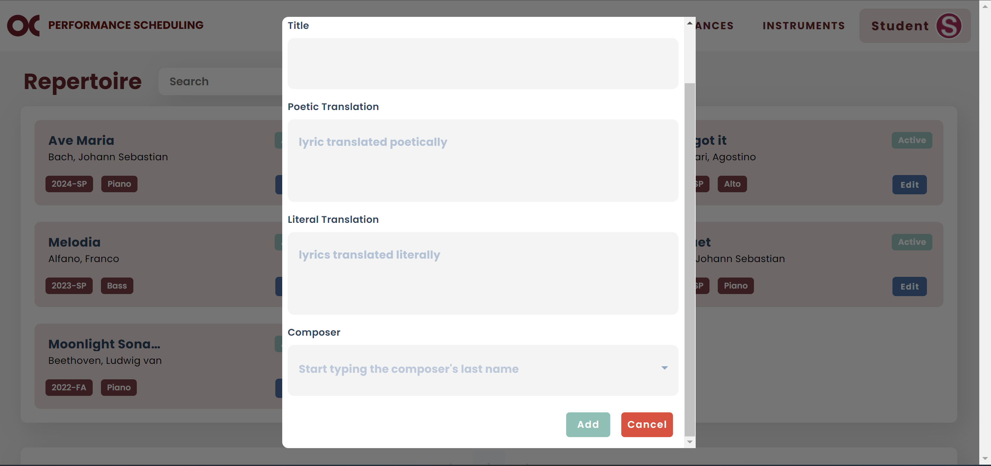

* 1. Now you can type the name of your piece and it will show in the list. If there are any duplicates, you can select any of them.
  2. If it is a vocal instrument, the poetic and literal translations will be displayed.
  3. If they are empty or wrong, click Edit Piece.

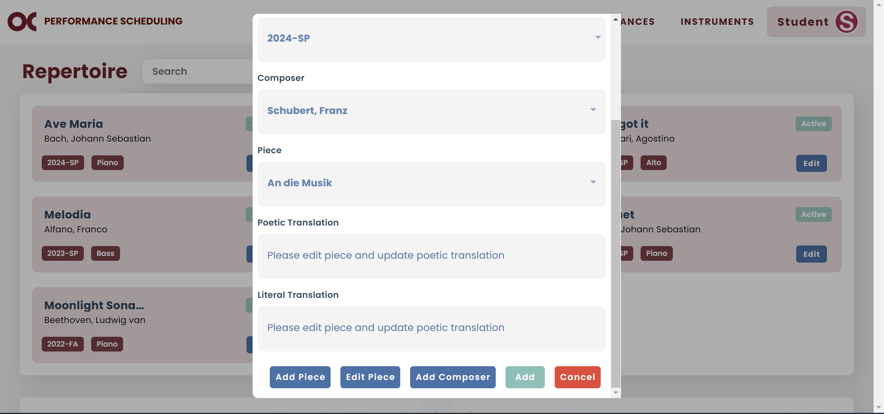

* 1. Enter the information, scroll down, and click Save.

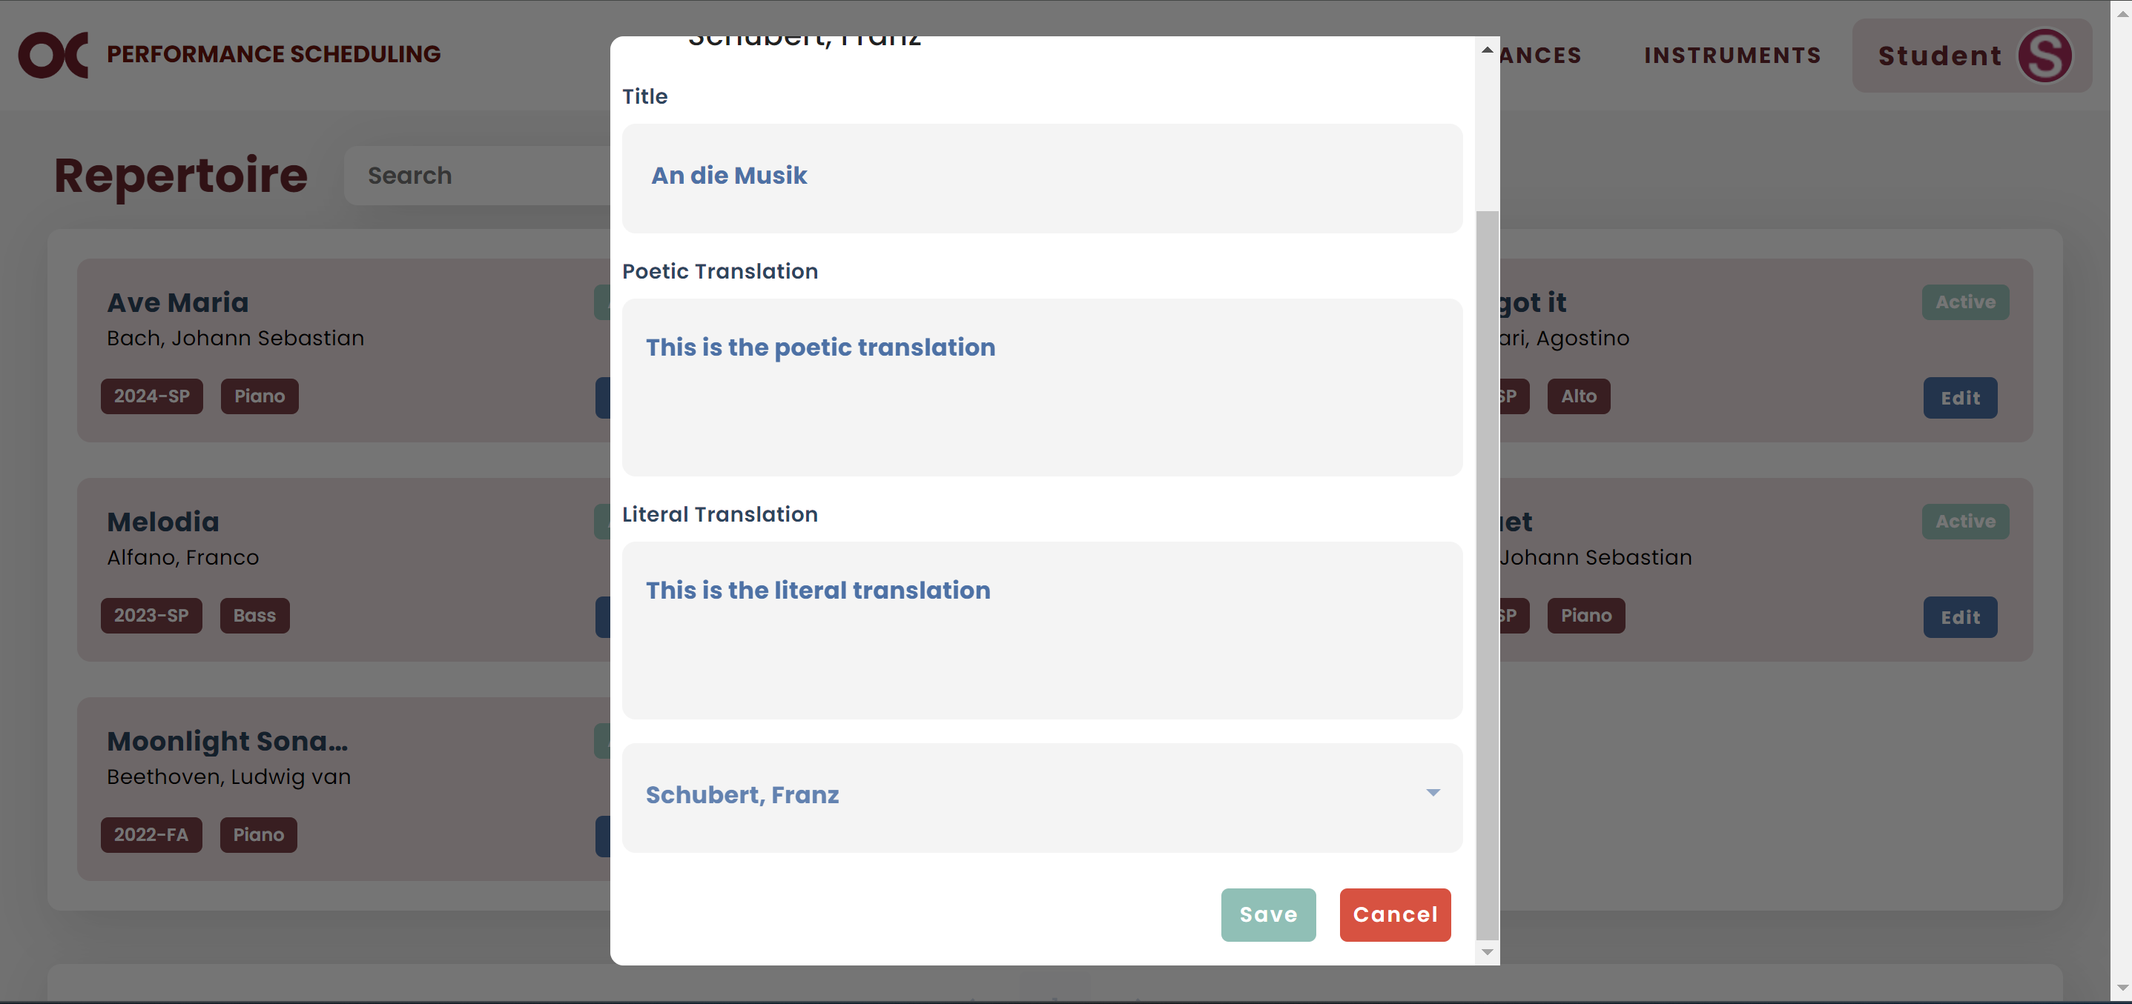

* 1. Now the information is displayed on the main screen.
  2. If all the information is correct. you can click Add to add this piece to your repertoire.

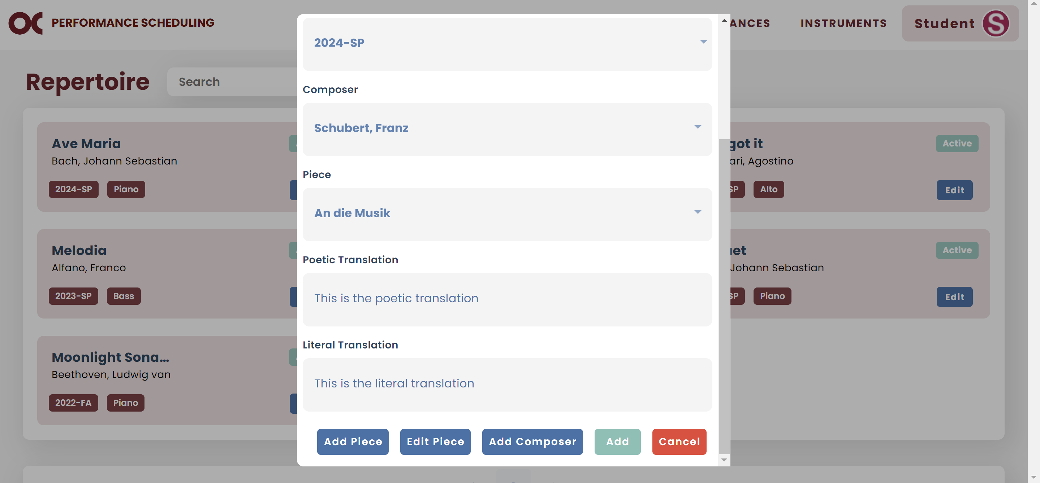

# Logout

* Click on Student and then Logout.

